PRIORITY SCHOOL

GUIDANCE



Table of Contents

Priority School Definition ………………………………………………………………………………………………............. 3

Priority District Definition ………………………………………………………………………………………………………. 3
Priority School and District Designation ………………………………………………………………….……...……….. 3

Priority School and District Requirements ……………………………………………………………………………….. 3

Overview of Priority School Support System ……………………………………………………………………………. 5

Priority Schools and Turnaround Principles …………………………………………………………………………….. 6

Priority School Principal Evaluation ………………………………………………………………………………………… 8

Funding ………………………………………………………………………………………………………………………………….. 8

School Level Leadership Teams …………………………………………………………….…...……………………………. 8

School Leadership Teams …............................................................................................................................. 9

School Leadership Team Responsibilities ………………………….…………………………….……………. 9
Data-Driven Decision Making …………………………………………………….…………………………………………….. 11
Data Retreat …………………………………………………………………………………………………………........... 11
Ongoing Use of Data to Inform Decision Making ………………………………………………………........ 12
Targeted Interventions ……………………………………………………………………………………………………………. 13
Reading Interventions …………………………………………………………………………………………………. 13
Mathematics Interventions …………………………………………………………………………………………... 13
Behavior and Attendance Interventions ……………………………………………………………………..… 14
Other Interventions …………………………………………………………………………………………………...… 14
Family, School, and Community Engagement ……………………………………………………………………………. 14
State-Approved School Turnaround Teams ………………………………………………………………….…………... 15
Priority District Requirements ………………………………………………………...……………………………………..... 15
District Leadership Teams …………………………………………………………….…………………….…….…. 15
Exiting Priority School Status …………………………………………………………………………………………………... 16
Appendix A- Principal Performance Review …………………………………….………………………………….….… 17
Appendix B- South Dakota Leading Effectively Achieving Progress (SD LEAP) Users Guide……….... 20
Appendix C- SD LEAP School Turnaround Indicators…………………….………………………………………...… 32
Appendix D- Priority School SD LEAP Timeline ………………………………………...……………………...……….. 38
Appendix E- Goals and Objectives Form …………………………………………………………………………………… 40
Appendix F- School Survey of Effective Practices …………………………………………………………………….... 42

Priority School Definition
The South Dakota Department of Education (SD DOE), as part of its ESEA Flexibility Waiver, has identified a Priority School as a school that has an overall School Performance Index (SPI) score which ranks at/or below the bottom 5%. The total number of Priority Schools must be at least five percent of the Title I schools in the state. Other schools that may be identified as Priority Schools include a Title I or Title I eligible high school with a graduation rate of less than 60% over two consecutive years. A Priority School designation is for four years – consisting of an initial planning year and then three years of implementation.

Priority District Definition
If a district has at least one Priority School and at least 50% or more of its schools are Focus and/or Priority (Title and non-Title), the district is considered a Priority District. Only districts with three or more public schools may be identified as Priority Districts. A district will remain a Priority District for a minimum of four years.

Priority School and District Designations
Priority School and District designations are determined on an annual basis. Designations are assigned as part of the state Report Card process. Adjustments to all associated deadlines may be necessary depending on availability of assessment results.

Priority School and District Requirements
Once identified, Priority Schools and Districts will be required to implement a series of interventions to address the issue of low performance in their schools and districts respectively.
SD DOE will host a series of regional workshops to help guide Priority Schools and Districts through the implementation process.
The following table outlines the requirements for Priority Schools and Districts. These requirements are intended to build the capacity of the schools and districts to implement and monitor a cycle of continuous improvement, using data to drive decision making related to professional development, instructional practice, and classroom interventions. The continuous improvement cycle is based on the process of reviewing data, having candid discussions, and making decisions for achieving school success. Table 1 provides an overview of the Priority School requirements and additional requirements if the Priority School resides in a Priority District.
Table 1. Priority School and District Requirements
 | Priority School Requirements | Additional Requirements for Priority Districts
 | Priority Schools must set aside 10% of their school level Title I allocation to support professional development and/or meaningful classroom interventions | Based on SD DOE analysis of district data, Priority Districts may be required to set aside up to 5% of their district Title I allocation to pay for a DOE-assigned Technical Advisor
 | Form a School Leadership Team, including principal, to drive the continuous improvement process and create, implement, and monitor the school turnaround plan | Form a District Leadership Team to drive the continuous improvement process and create, implement and monitor the district turnaround plan
 | Use South Dakota Leading Effectively Achieving Progress (SD LEAP) online planning tool to assess, plan, implement, and monitor School Indicators of Effective Practice | District Leadership Teams will report to the school board at the time of designation and quarterly on the progress of the school turnaround plan. The school board agenda and minutes will reflect the progress report.
 | Engage in data driven decision making, including a two-day Data Retreat with a certified facilitator and continue to review student data throughout the year via school leadership team meetings
 | Implement targeted interventions and supports that align with the needs of students | Implement interventions and supports that align with the needs of its Priority Schools
 | Implement targeted professional development (PD) that addresses PD needs of teachers identified through review of student achievement data | Support schools in providing PD that fits teachers’ needs and aligns with the reason for priority designation
 | SD DOE will assign a School Support Team (SST) member | SD DOE will assign a Technical Advisor to Priority Districts as needed.
 | Review the performance of the Priority School principal to ensure ability to lead turnaround (See Appendix A)
 | Build effective home, school, and community partnerships that focus on student growth and learning by providing continuous staff PD (examples include Family Friendly Walkthroughs and Beyond the Bakesale Class) and develop clear expectations for implementing research-based practices

Overview of the Priority School Support System
DATA
Meaningful Supports

Priority Schools and Turnaround Principles
SD DOE has developed a system of supports and interventions aligned with the turnaround principles identified by the United States Department of Education. Table 2 provides an overview of the alignment of these supports and interventions to the principles. Each Priority School is required to address all seven turnaround principles for three consecutive years of implementation and have me the required AMO targets before the school may apply to exit Priority status.
Table 2. Overview of Turnaround Principles and SD DOE Priority School Requirements
Turnaround Principle | SD DOE Requirements
1.Providing strong leadership by:  (a) reviewing the performance of the current principal;  (b) either replacing the principal if such a change is necessary to ensure strong and effective leadership, or demonstrating to the SEA that the current principal has a track record in improving achievement and has the ability to lead the turnaround effort; and  (c) providing the principal with operational flexibility in the areas of scheduling, staff, curriculum, and budget. | - Form a School Leadership Team, including principal, to drive the continuous improvement process  - Complete the Survey of Effective Practices and use data to drive decision making and PD  - Review the performance of the Priority School principal to ensure ability to lead turnaround (Appendix A)  - Ensure PD opportunities for principal are aligned to school needs  - See SD LEAP indicators that address this principle (Appendix C)
2. Ensuring that teachers are effective and able to improve instruction by:  (a) reviewing the quality of all staff and retaining only those who are determined to be effective and have the ability to be successful in the turnaround effort;  (b) preventing ineffective teachers from transferring to these schools; and  (c) providing job-embedded, ongoing professional development informed by the teacher evaluation and support systems and tied to teacher and student needs. | - Complete the Survey of Effective Practices and use data to drive decision making and PD  - Implement targeted PD that addresses needs of teachers identified by review of student achievement data  - Principals are required to monitor teacher performance; see SD LEAP indicators that address this principle (Appendix C)  - Principals are required to conduct annual evaluation of all teachers, using state teaching standards (Charlotte Danielson Framework) and student growth data
3. Redesigning the school day, week, or year to include additional time for student learning and teacher collaboration. | - Complete the Survey of Effective Practices  - Extend or restructure the school day/week/year, in order to 1) provide time for collaboration and PD for staff 2) to provide additional time for students to have access to high quality instruction  - See SD LEAP indicators that address this principle (Appendix C)
4. Strengthening the school’s instructional program based on student needs and ensuring that the instructional program is research-based, rigorous, and aligned with State academic content standards. | - Complete the Survey of Effective Practices and use data to drive decision making about instructional programs and classroom interventions  - Complete Goals and Objectives Form  - Implement targeted interventions and supports that align with the needs of students  - See SD LEAP indicators that address this principle (Appendix C)
5. Using data to inform instruction and for continuous improvement, including by providing time for collaboration on the use of data. | - Engage in data driven decision making, including a two-day Data Retreat with a certified facilitator and continue to review student data throughout the year via school leadership team meetings  - Complete the Survey of Effective Practices and use data to drive decision making about instructional programs and classroom interventions  - Complete Goals and Objectives Form  - See SD LEAP indicators that address this principle (Appendix C)
6. Establishing a school environment that improves school safety and discipline and  addressing other non-academic factors that impact student achievement, such as  students’ social, emotional, and health needs. | - Complete the Survey of Effective Practices and use appropriate data to drive decisions related to establishing a healthy school environment  - Schools may implement activities such as Positive Behavioral Intervention and Supports, safe school walk-throughs, nutrition and health programs in order to address identified needs  - See SD LEAP indicators that address this principle (Appendix C)
7. Providing ongoing mechanisms for family and community engagement. | - Participate in state-sponsored family engagement training as needed and as funds allow  - Complete the Survey of Effective Practices and use appropriate data to drive decisions related to improving family and community engagement. Schools must consider additional family engagement activities and other ways to create or enhance community partnerships.  - See SD LEAP indicators that address this principle (Appendix C)

Priority School Principal Evaluation
All South Dakota public school districts are required to complete the Gap Analysis and Planning Guide by June 30, 2015 as provided and outlined by the Division of Assessment and Accountability. Additionally, in order to be considered fully implementing Turnaround Principle 1, Priority Schools must complete the Principal Performance Review (Appendix A) by April 30th. For questions please contact Matt Gill at Matthew.Gill@state.sd.us.

Funding
Title I funding will be used to implement meaningful interventions at schools, both in terms of helping individualize instruction for students and for professional development activities designed to help educators better meet the needs of their students. Priority Schools must set aside 10% of their school-level Title I allocations to implement targeted interventions or professional development as approved by SD DOE. The set-aside must be documented in the Consolidated Application for years 1, 2, and 3 of implementation.
Based on available funding, SD DOE may provide funds to support the implementation of targeted interventions and/or professional development, through an application process.

School Level Leadership Team
SD DOE recognizes that local leadership plays an integral role in fostering effective change within their educational community. SD DOE believes that school turnaround is best accomplished when directed by the people closest to the students. While the state provides a framework for the process, each school team applies its own ingenuity to achieve the results it desires for its students.

School Leadership Team
To start the focused improvement process, immediately after being identified as a Priority School, the school needs to identify a School Leadership Team generally consisting of three to six members. This team must consist of the following members:
- Principal from Priority School
- Teachers who lead instructional teams
- School Support Team member
The other team members may consist of the following:
- Title I Director
- Curriculum Director
- Assessment Director
- Special Education Staff
- Teachers
- Parents
- Federal Programs Director
- Business Manager
- Superintendent
- School Board Members
- 21st Century Community Learning Staff
- Any outside coaches the school is working with to facilitate school turnaround
Effective teams will lead their schools in continuous improvement, offer strong leadership, help ensure that instruction is of the highest quality, and help set goals and trajectories to support student success.
At a minimum:
- Meetings of the School Leadership Team need to occur at a minimum of once a month (suggested for two to four hours a month).
- This team structure should be officially incorporated into the school turnaround plan and the school governance policy.
- The team needs to prepare agendas and maintain minutes for each meeting.
- The principal will play a key role on these teams and must help to ensure that the focus remains on instructional improvement and student learning outcomes.

School Leadership Team Responsibilities
The School Leadership Team needs to regularly look at school performance data and aggregated classroom observation data and should use this data to make decisions about school turnaround and professional development needs.
The School Leadership Team should help guide the work that school level Instructional Teams (organized by grade-level, grade-level cluster, or subject area) do to develop and refine units of instruction and to review student learning data. If not already developed, the School Leadership Team needs to ensure that Instructional Teams are developed and that these Instructional Teams meet for blocks of time (suggested four to six hours a month; whole days before and after the school year) sufficient to complete their planning work.
The School Leadership Team will be responsible for developing a school’s turnaround plan, entering goals, and tracking progress on a regular basis. The image below illustrates the responsibilities of School Leadership Teams in the turnaround process.

Four lenses of data
Multi-day process
Data Retreat – Needs Assessment
Enter goals – Track progress
Planning time
Develop and refine units of instruction
Review student learning data
Develop Instructional Teams
Guide work of school instructional teams
Prepare agendas and maintain minutes
Meet regularly
Priority School

School Level Leadership Team

Informs instruction
Develop School Turnaround Plan

Data-Driven Decision Making
Data should be used continually to inform progress and set goals and trajectories within each school and district. The use of data comes in two pieces: The data retreat and the ongoing use of data to inform decision making (including the provision of targeted professional development).

Data Retreat
Following identification as a Priority School, each school will create a School Leadership Team if one is not already in place. This team must attend a two-day regional retreat sponsored by SD DOE, if provided, prior to the start of the implementation year. If the regional retreat is not available, the school will contract with an SD DOE-approved Data Retreat Facilitator to provide the services. During the retreat process, a comprehensive needs analysis will occur. The analysis will encompass the four lenses of data: student achievement, professional practices, programs and structures, and family and community, as well as be aligned to the 7 Turnaround Principles. At the end of this retreat, goals and objectives will be set using the resulting data and submitted via the SD LEAP system using the Goals and Objectives Form.
It is imperative that the data retreat take place prior to the start of the next school year, preferably in the spring or early summer, to ensure each Priority School has the appropriate data to drive their decisions about targeted interventions and professional development. The latter part of the data retreat will include time for the School Leadership Team to enter information into SD LEAP in order to begin their continuous improvement process. The resultant goals and the first set of progress monitoring data should be entered into SD LEAP no later than October 15th and shared with all school staff members.
The South Dakota Data Retreat process was developed to give districts and schools a consistent and reliable method to understand how to use data to inform decision making at the classroom, school, and district level. The main component of the process is a comprehensive, two-day Data Retreat. The fidelity of the process is ensured by the following:
- The Data Retreat Facilitator has received training and is on the state’s list of approved facilitators.
- The initial retreat is held prior to the submission of the Consolidated Application. .
- Data are analyzed using the four lenses: 1) student data; 2) family and community; 3) programs and structures; and 4) professional practices.
- These four lenses, aligned with the Seven Turnaround Principles, inform a holistic analysis of school performance and culture.
By the end of the retreat, the School Leadership Team should have a solid understanding of the factors impacting student achievement and should have developed concrete steps that need to be taken to effectively address identified needs. At a minimum, the results of the retreat should be used to:

- write goals and objectives using data from all four lenses;
- update schoolwide plans with the current information;
- determine next steps for the School Leadership Team;
- assist the team in developing and updating the turnaround plan;
- create professional development plans based on identified needs; and
- inform ongoing analysis throughout the school year, using reliable indicators for student progress.
- determine how information and decisions will be shared with other staff members at the school level
In instances where a school has a schoolwide plan that is separate from the school improvement accreditation plan, both plans should be updated with current data and goals. This data and planning should be used to inform the consolidated application process.
SD DOE anticipates offering regional Data Retreat sessions in the spring/summer of each school year, in order to ensure a consistent approach to the data retreat process. This would not prohibit Priority Schools from contracting with an approved Data Retreat Facilitator if they so choose, after attending the initial off-site retreat (if offered). More information on the schedule for these regional data retreats will be posted to SD DOE’s website and announced to Priority Schools via email.

Ongoing Use of Data to Inform Decision Making
School Leadership Teams should meet at least two to four hours per month to evaluate the progress they are making within their school. As each team meets, they should be looking at data that is used to support their school goals and at the information and data from daily activities within the school.
School Leadership Teams should be meeting with grade level or content area instructional teams to review data points and progress towards implementation. These meetings should be used to evaluate the efficacy of instructional strategies and to transform interventions to better meet student needs.
The specific data that needs to be examined will differ based on the goals and strategies identified at each school. Some examples of data to monitor may include, but not limited to:
- Student demographics, including information on gender, race/ethnicity, special education, migrant, English Language Learner, and other sub-group status
- State assessment results for students as a whole and by subgroup
- Attendance records
- Discipline referrals
- In-school and out-of-school suspensions
- Any information available on student grades
- Any information on performance of students who are below grade level in reading or mathematics
- Any formative assessment data available
- Teacher quality
- Teacher attendance
- Number of parent conferences
- Number of classroom observations and instructional walk-throughs
- Number of students transferring in and out of the school

Targeted Interventions
As schools are going through the process of reviewing data, it is expected that they will find areas in which meaningful targeted interventions are needed to help drive school turnaround. While there are many options out there that schools can choose from, it is important that schools choose interventions that are research-based and that will help them to target interventions to those groups in their schools who need them the most. Schools should be looking at current programs and determining whether these are the correct programs to be implementing, whether programs could be implemented with greater fidelity, and what gaps exist that other interventions may help address.
At a minimum, schools should:
- Be using an adaptive reading assessment program that provides grade equivalency, Lexile scores, or some other meaningful measure of student progress and achievement.
- Provide some opportunity for individualized math interventions that help students to target missing skills based on current ability level. At the fifth grade or higher levels, this should specifically include an option for testing students for algebra readiness.
- Address issues related to classroom management, attendance, or school climate that could be contributing to student achievement issues.
- Provide staff professional development because of its critical role in helping foster school-wide change. SD DOE will be able to provide some assistance in identifying appropriate experts to help with some of these PD needs.

Reading Interventions
Research shows that it is critical for students to be able to read at grade level early in their academic careers if they hope to succeed. As schools are looking at their data and deciding what interventions may help address areas where reading gaps exist, they should be using some sort of adaptive reading assessment program to help determine student growth on a regular basis. Where reading gaps exist, schools should monitor student progress a minimum of twice monthly.

Mathematics Interventions
Students who have developed strong math skills, in particular strong pre-Algebra skills by the end of the eighth grade, are more likely to succeed in high school and college. To that end, schools should be working to ensure that students have strong foundational math skills. Individualized math interventions and regular math assessments should play an integral role in Priority Schools’ improvement plans. Where math gaps exist, schools should monitor student progress a minimum of twice monthly.

Behavior and Attendance Interventions
Priority Schools may also identify attendance and classroom management as issues that are impacting student success. SD DOE programs such as Positive Behavioral Interventions and Support and Jobs for America’s Graduates may be used to intervene in these situations. Schools are encouraged to contact SD DOE for technical support surrounding these issues.

Other Interventions
Some Priority Schools may find that faculty and other school leaders need additional professional development opportunities to help address needs within the school; these may include, but are not limited to:
- Training and work in co-teaching/inclusion
- Training and work in data-driven improvement
- Training in differentiated instructional strategies
- Training in formative assessment
- Training in quality teaching and instructional supervision
- Training in student engagement
- Student support services expansions
- Other reading and writing instructional strategies and programs
- Other mathematics instructional strategies
- Training and programs targeting meaningful improvement in school culture
- Training in classroom management

Family, School, and Community Engagement
Priority schools must invite families to participate in the school’s school improvement process and activities and provide opportunities to engage parents in the process. Families and the community are an essential piece to the school improvement process. District and leadership teams must include families and communities in the work of school improvement. Family engagement is a shared responsibility of families, schools, and communities. The research on family and community engagement correlates family engagement with student achievement. Family and community engagement strategies should be intentionally aligned with student learning and achievement.
As a reform strategy family and community engagement should be systemic, integrated, and sustained.
ESEA Section 1118 requires all Title I schools to have Parent Involvement Policies at the district and school level as well as a school/home compact. These documents should be developed with a purposeful link to learning and achievement. These documents should be developed with families and with the intention to create a solid foundation for communication and partnerships between school staff and families.
When schools and communities support sustained family engagement linked to learning there is a direct correlation to improved outcomes for students. (National Policy Forum Family, School, and Community Engagement Beyond Random Acts Family, School, and Community Engagement as an Integral Part of Education Reform; Heather B. Weiss, M. Elena Lopes, and Heidi Rosenberg Harvard family research Project)

State-Approved School Turnaround Teams
SD DOE will utilize the expertise of qualified professionals to assist schools and districts in their turnaround efforts.
- Technical Advisors
Based on SD DOE analysis of district data, Priority Districts may be required to set aside up to 5% of their district Title I allocation to pay for a DOE-assigned Technical Advisor. These Technical Advisors will act as a final approval for all district-level decisions being made regarding curriculum, staff assignments, budgetary requests, professional development, and other interventions aligned to the turnaround principles. Technical Advisors also are responsible for regularly communicating with SD DOE, SSTs assigned to schools in the district, and with district governance to include school boards. Through regular reporting, SD DOE will work with Technical Advisors to identify additional support districts may need.
- School Support Team Members (SST)
Each Priority School will have a School Support Team (SST) member selected and assigned by SD DOE. SSTs will support schools as they go through the data analysis process and plan for and implement interventions aligned to the turnaround principles. They will monitor progress of the turnaround plan and provide technical assistance. SSTs are expected to interact with School Leadership Teams on regular basis.
- Data Retreat Facilitators
SD DOE will provide Priority Schools with either 1) opportunities to attend regional data retreat summits or 2) a list of approved Data Retreat Facilitators. These facilitators have been trained to take schools through a comprehensive data analysis process that is inclusive of the four lenses of data in the South Dakota Data Retreat model.

Priority District Requirements
Priority Districts, as defined earlier, have at least one Priority School and 50% or more of their schools identified as Priority and/or Focus Schools. The goal of a Priority District should be to achieve efficient and effective district policies, programs, and practices to enhance growth in student learning through differentiated supports to all schools.

District Leadership Teams
When a district is designated a Priority District, the district will create a District Leadership Team consisting of four to six members. This team must consist of the following members:
- Superintendent or Assistant Superintendent
- Principal(s) from Priority and/or Focus Schools
- School Support Team member and Technical Advisor (if applicable)
The other team members may consist of the following:
- Title I Director
- Teachers
- School Board Member
- Parents
- Federal Programs Director
- Business Manager
- Special Education Director
- Curriculum Director
The District Leadership Team will be responsible for:
- Meeting with School Support Team member on a regular basis to develop protocol for providing differentiated support to each of the schools within the district.
- Meeting with the principal(s) of each Priority and/or Focus School, as a team, on a quarterly basis to review and analyze data and use the information to guide decision making.
- Communicating with the School Board at the time of designation and quarterly throughout the process. This communication must be detailed in the School Board agenda and minutes.

Exiting Priority School Status
Schools identified as Priority Schools may apply to exit this designation after four years, if they have met the required criteria, which demonstrates potential for sustained improvement and growth.
- The school is no longer designated as a Priority School based on current year calculations – meaning its overall SPI score is above the bottom 5 percent.
- The school’s Gap Group and Non-Gap Group meet their AMO targets in reading and math for three consecutive years.
- The school is faithfully implementing and addressing the required interventions and turnaround principles, as evidenced through SD DOE monitoring.
For Title I and Title I eligible high schools identified as Priority Schools because of their graduation rate, the school may apply to exit the designation after it has met the above criteria and when it has a graduation rate of 70 percent or above for the last two school years.

Appendix A
PRINCIPAL PERFORMANCE REVIEW - Priority Schools
(This form must be completed for each Priority School by April 30.)
District Name:
School Name:
Name of Principal SY 2014-2015:
Name of Principal SY 2015-2016:

- Have you completed a review of the performance of the principal who was employed at the time the school was identified as a Priority School?
If no, do you plan to complete an evaluation prior to the beginning of SY 2015-2016?
If yes, what was the outcome?
When was the review of the principal completed?

Answer questions 2-4 if the principal was not retained. Otherwise, skip to question 5.
- If a new principal has been hired during school year 2014-15 or will be hired as a principal for school year 2015-16, provide an explanation why this new candidate is equipped to lead the turnaround process.

- Describe how you are planning to offer this principal operational flexibility necessary to lead the turnaround effort.
- If a new principal has not been selected to replace the previous principal, explain who is currently leading the turnaround effort and outline the plan for hiring a new principal.

Answer questions 5 and 6 if the principal was retained.
- Professional Practice
  - Explain how the principal met each of the Professional Practice domains.
Domain 1 – Vision and Goals
Domain 2 – Instructional Leadership
Domain 3 – School Operations and Resources
Domain 4 – School, Student and Staff Safety
Domain 5 – School and Community Relationships
Domain 6 – Ethical and Cultural Leadership
  - Identify the data used to determine this principal has the ability to lead the turnaround effort.

Evidence of Professional Practice located in SD LEAP

Growth goals

School Improvement Plans developed by the principal

Community involvement

Past evaluations

School climate data

Evidence of coaching/mentoring

Evidence of professional development

Professional reviews using the Principal Effectiveness Professional Practice rubrics

Principal Professional Growth Plan

Other data demonstrating ability to lead the turnaround effort (identify below)

  - Attach artifacts which provide documentation and reflect why it was decided to retain this principal, or use the text box below to state which active indicators from SD LEAP provide evidence. A list of possible artifacts related to the South Dakota Professional Practice domains is located on page 21 of the Principal Effectiveness Handbook.

- Student Growth
  - Provide a summary of why you feel this individual has a track record of improving student achievement.
  - Identify the data used to determine this principal has a track record of improving achievement.

SD LEAP Active Indicators

SLO Growth Score (Teacher SLO Attainment)

SPI, AMO, and/or GAP growth goal data, which is required for Principal Effectiveness

Results of benchmark assessments with progress monitoring, including Dibels, Aims Web, etc.

Graduation/completion rate data

State assessment scores for the school(s)

Information on IEP completion

  - Attach artifacts which provide documentation for student growth, or use the text box below to state which active indicators from SD LEAP provide evidence. A list of possible artifacts, which include student growth artifacts, is located on page 21 of the Principal Effectiveness Handbook.

If the principal of the Priority School is the same individual as the district superintendent, the superintendent should complete this form and send it to South Dakota Department of Education, Division of Assessment and Accountability, 800 Governors Drive, Pierre, SD 57501, for approval. Once approved at the state level, it will be sent to the Board President of the school district for final sign off.

__
Signature of person completing form Date Submitted

__
Approved by SD Department of Education Date Approved

__
Approved by School Board President (if required) Date Approved

Appendix B

South Dakota Leading Effectively Achieving Progress (SD LEAP) User Guide

SD LEAP (Indistar®) is a web-based planning tool designed to guide schools and School Leadership Teams in planning and charting the improvement process. Within the SD LEAP system are indicators of evidence-based practices that have been demonstrated to improve student learning. To work effectively, the indicators must be discussed honestly and openly, in an effort to ensure that practices at the school contribute to student learning. There is no one right answer or one-size-fits-all approach to effecting meaningful change at the school. What is essential is that teams are having candid discussions about how to impart change, and that ambitious but achievable goals are set to help increase student performance.
Based on the way that the SD LEAP system operates, the School Leadership Team will first assess its current level of implementation related to the indicator to form a clear understanding of what is occurring in the school. Once that baseline is established, the team will create a description of how the indicator will look when fully implemented and then create a step-by-step plan to achieve the desired outcome.
A set of pre-defined School Turnaround Indicators of Effective Practice will be loaded into SD LEAP for schools to begin reviewing; the list of all indicators can be found in Appendix C. These indicators are meant to help guide Priority Schools through the improvement process, and track the minimal required elements. This information will be included on the regular reports sent to SD DOE via SD LEAP. A timeline of indicators to be assessed, planned, and monitored can be found in Appendix D for Priority Schools.
The following pages explain the process of SD LEAP and include snapshots of the various steps within the system.

Logging In and the School Dashboard

The School Leadership Team will log into SD LEAP through the website www.indistar.org. SD DOE will provide each school team with a user name and password after being identified as a Priority School.

Once the team has logged into the system, the School Dashboard will appear. This is the control center for the SD LEAP system. The tabs on this page will bring users to the indicators by clicking on home. Separate sets of indicators are listed here. Priority Schools should select the School Turnaround Indicators as the indicators they will work on.

Forms due at each reporting date can be found under the Forms to Complete tab. When reports are ready to be submitted, the team will go to the tab labeled Required Report and hit the submit button. Additional resources can be found under the tab labeled Docs & Links.

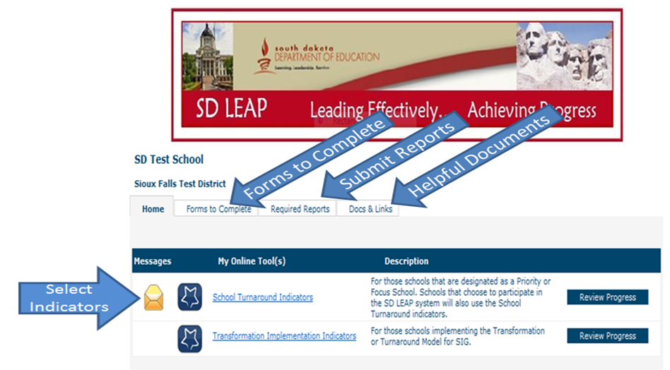

Main Menu
Once the team selects the School Turnaround Indicators, the main menu will pop up. The main menu is where the work takes place. The snapshot below shows the features of the main menu. The descriptions below explain the various steps.

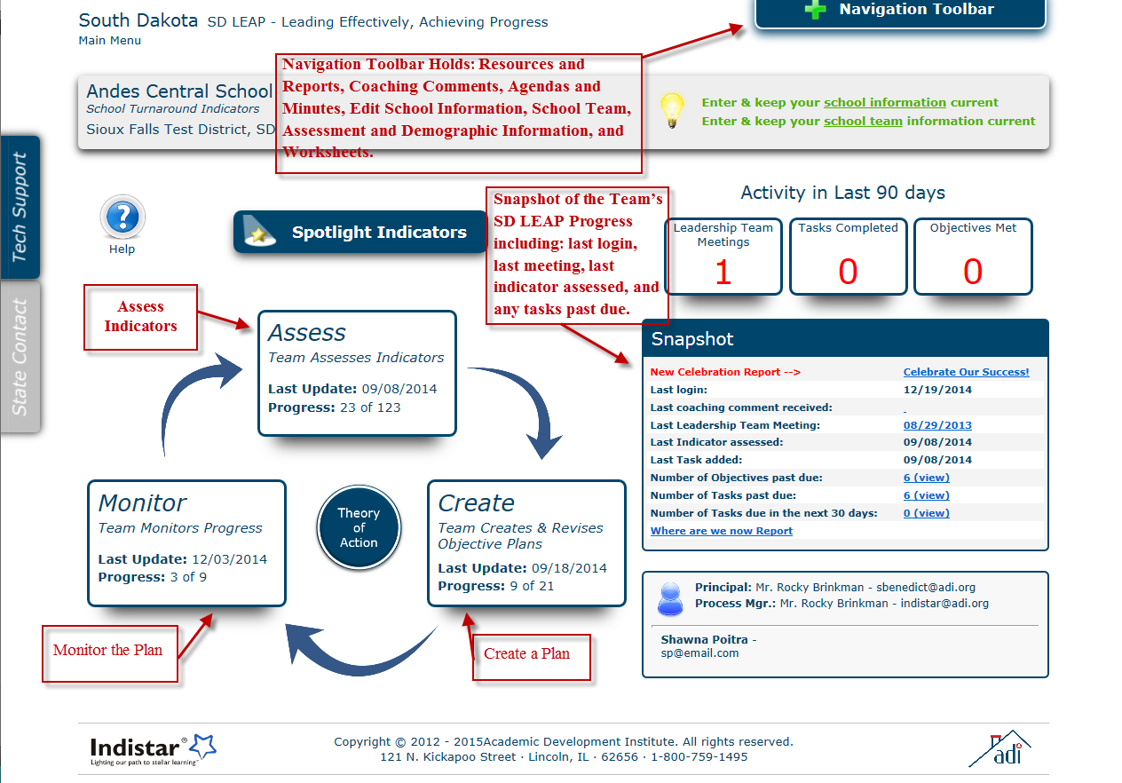

Steps of SD LEAP
- Edit School Information
SD DOE will register the school within SD LEAP. Schools will verify that all school information is accurate and update as needed by clicking on Edit School Information.

- Form the School Leadership Team.
Schools will identify School Leadership Team members and enter them into the system. It is important to keep the team members information up-to-date, as it will be used continuously throughout the process to identify parties responsible for specific tasks and to monitor attendance at meetings. The school team will designate a Process Manager to guide their work within the tool and complete tasks such as entering the data and creating agendas/minutes. The team will work together to examine the indicators; the Process Manager will be entering the information into the tool.

- Assess School Turnaround Indicators (Assess)
Schools will review the School Turnaround Indicators based on a schedule provided by SD DOE (See Appendix D). The team will assess their current level of implementation, based on a rating of fully, limited, or no implementation, and enter this information into the system.

To adequately assess an indicator, teams must provide a detailed description of their current level of implementation. This description should cover the 5 W’s (who, what, when, where, why). A person not on your school team should have a good understanding of the indicator and how it is currently implemented in your school. See example below:

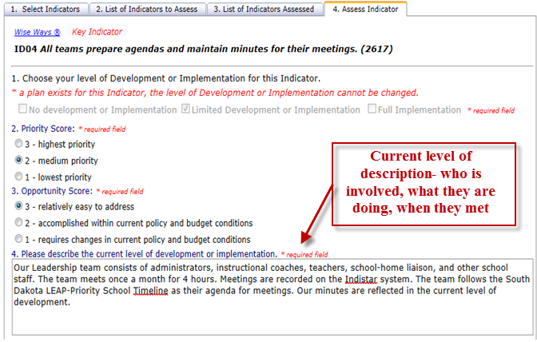

- Create School Turnaround Plan (Plan)
Based on the team’s assessment of each indicator, schools will create plans that include concrete, achievable tasks for each indicator that had no or limited development. See example below:

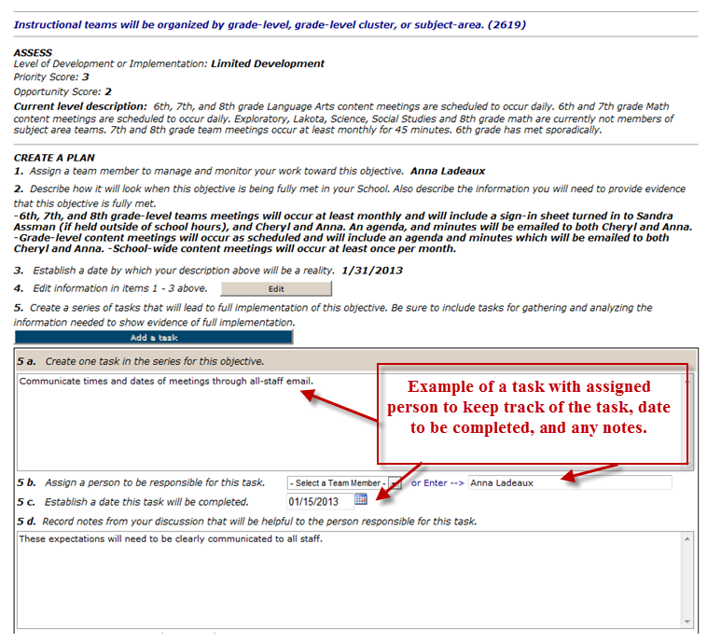

- Self- Monitor the School Turnaround Plan (Monitor)
The School Leadership Team will self-monitor their progress toward completing tasks and achieving full implementation of indicators. The continuous improvement process within SD LEAP enables teams to review and revise their work as necessary throughout the year.

As schools are using SD LEAP to monitor their progress and are regularly looking at data, they should be asking themselves the following questions:
  - Where are we now? What caused the school to be a Priority School?
  - Where do we want to be? What will it look like as we close the gap(s)? If operating a schoolwide program, how do the indicators relate to the schoolwide plan?
  - How will we get there? What strategies are we using to drive rapid improvement?
  - How will we know we are on the right track? What data do we need to be looking at regularly?
  - How will we sustain focus and momentum? How do we use data to modify our strategies?

The following steps will assist school teams as they monitor their plans.
1. School teams will review tasks and revise when necessary as new data is being generated throughout the year. Teams will click on the Monitor box, circled below to review/revise the tasks.
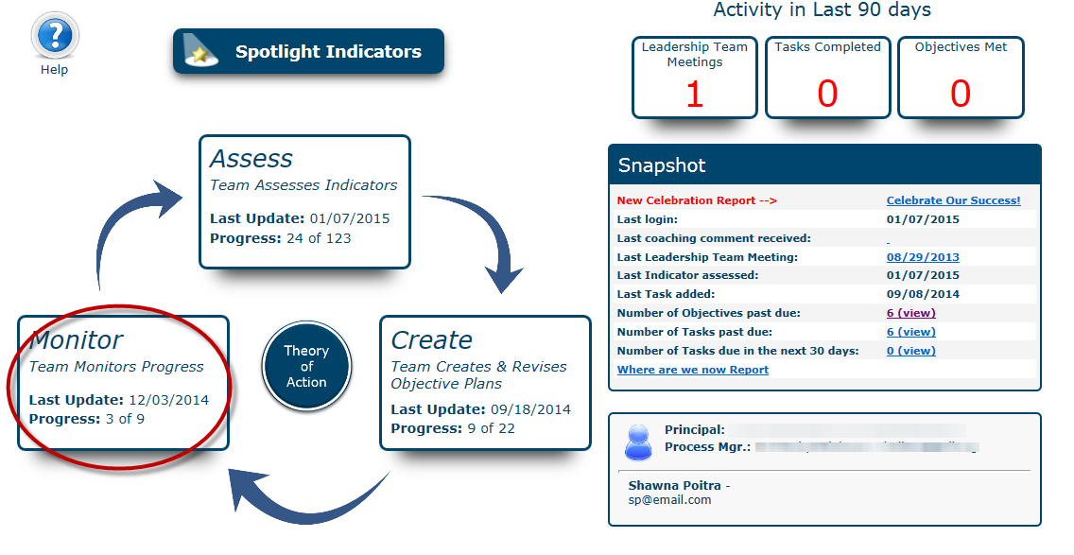

2. Once the team clicks on the Monitor box, the indicator (now called an objective), the assessment information, planning information, and tasks will appear. Clicking on the task, circled below, will display the task to review and revise.
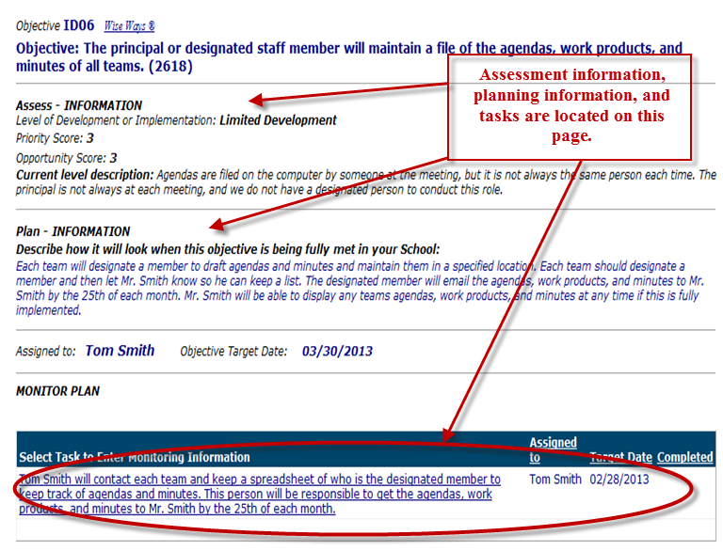

3. Once the task is displayed, the team will discuss whether each task has been completed. If completed, enter the completion date as well as any comments. At this time, the team can choose to save and update or delete the task.
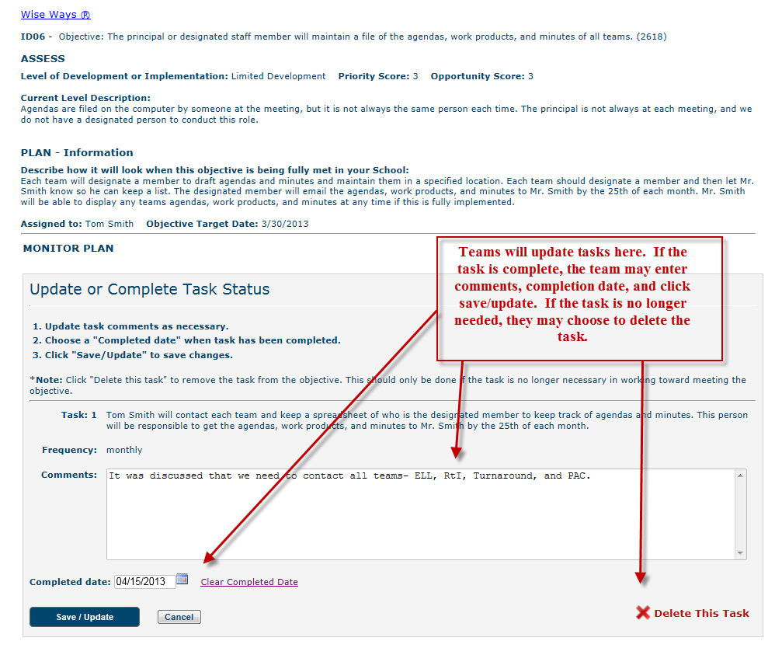

4. As part of the monitoring process, school teams should review the comments created by their School Support Team member (assigned by SD DOE to assist the school in this process) to monitor the indicators. To review a comment and respond, click on the appropriate comment.
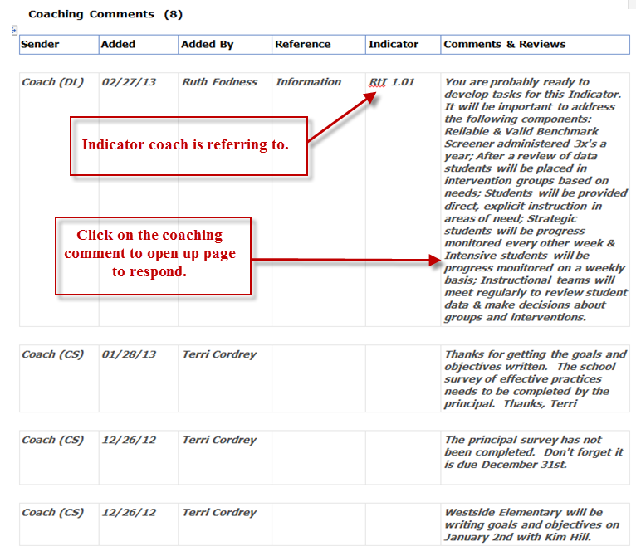

- Agendas and Meeting Minutes (Plan Your Meeting)
Agendas and meeting minutes are an important step in the School Leadership Team’s work. The team will post their meeting agenda and meeting minutes on a monthly basis within SD LEAP. The system will maintain all agendas and minutes entered and keep a record of them. This is valuable so as new members enter the team, they are able to look at the history of the meetings and review decisions made by the School Leadership Team.
Below is a snapshot of the agendas and meeting minutes in SD LEAP.
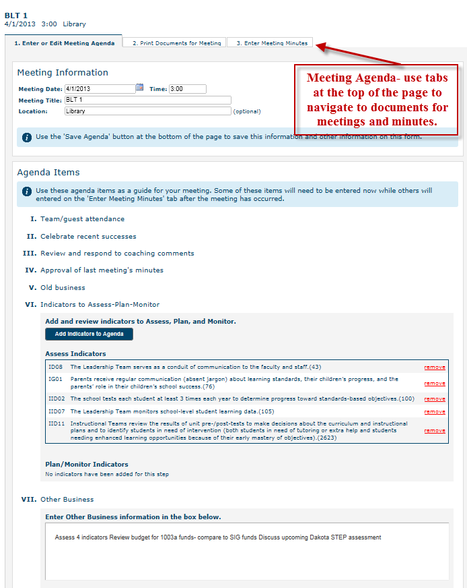

Monitoring Requirements
The School Leadership Team will be responsible for developing a school’s turnaround plan, entering goals, and tracking progress on a regular basis within the SD LEAP system. Reporting within the SD LEAP system will be due on: October 15th; January 15th; and May 15th. Monitoring documents will be found in the SD LEAP system. SD DOE along with School Support Team Members will monitor the progress of the indicators through the documents and provide necessary feedback and technical assistance. SD DOE’s Statewide System of Recognition, Accountability and Support (SSRAS) team will meet to review this data within two weeks of each submission date. Within one month of the submission, Priority Schools and Districts will receive a feedback report from SD DOE. Monitoring documents included within SD LEAP are:

- School Turnaround Plan
This document is submitted to the state three times a year and is generated as the teams add information to the system. The plan includes the indicators assessed, planned, and monitored by the School Leadership Team and is regularly being reviewed and updated.
- Goals and Objectives Form
This document is submitted three times a year and will list the reading, math, and other goals (if necessary) and the benchmarks to meet those goals. Names of assessments (district and school level), along with dates and results, will be recorded. See Appendix E.

- School Survey of Effective Practices
This document is submitted twice a year and will evaluate practices within the school that align to the Turnaround Principles. See Appendix F.

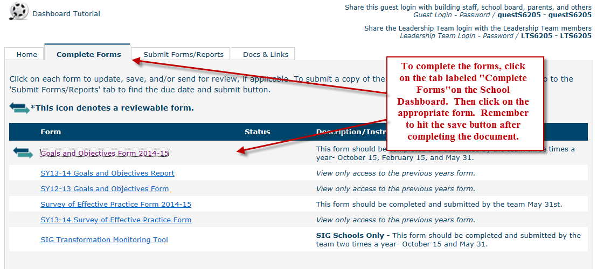

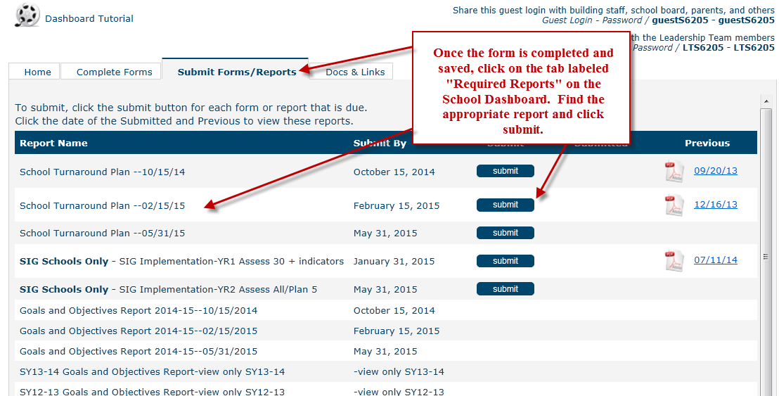

Annual monitoring should provide sufficient evidence that needed interventions are being faithfully implemented. SD LEAP is used as the primary tool for reporting this information. School Support Team members will work with SD DOE to review evidence submitted through SD LEAP to ensure that progress towards school turnaround is being made. Evidence examined includes School Leadership Team meeting agendas and minutes and the School Turnaround Plan, as well as all other forms and data entered into SD LEAP.

SD LEAP and Turnaround Principles
The SD LEAP online planning tool provides schools access to research-based indicators of effective practice that help drive the improvement process at the school and classroom level. SD DOE has identified a set of indicators – the School Turnaround Indicators – within SD LEAP that are critical to beginning the continuous improvement process. Priority Schools are provided a timeline to guide their work within the SD LEAP system (Appendix D). A full list of indicators aligned to the turnaround principles can be found in Appendix C.

Appendix C
SD LEAP School Turnaround Indicators
Turnaround Principle 1
Providing strong leadership by:
(a) reviewing the performance of the current principal;
(b) either replacing the principal if such a change is necessary to ensure strong and effective leadership, or demonstrating to the SEA that the current principal has a track record in improving achievement and has the ability to lead the turnaround effort; and
(c) providing the principal with operational flexibility in the areas of scheduling, staff, curriculum, and budget.
School Leadership Teams
ID01 |  |  | A team structure is officially incorporated into the school turnaround plan and school governance policy. (2745)
ID02 |  |  | All teams have written statements of purpose and protocols for their operation. (2616)
ID03 |  |  | All teams operate with work plans for the year and specific work products to produce. (38)
ID04 | KEY |  | All teams prepare agendas and maintain minutes for their meetings. (2617)
ID06 |  |  | The principal or designated staff member maintains a file of the agendas, work products, and minutes of all teams. (2618)
ID07 | KEY |  | A Leadership Team consisting of the principal, teachers who lead the Instructional Teams, and other key professional staff meets regularly (twice a month or more for an hour each meeting). (42)
ID08 |  |  | The Leadership Team serves as a conduit of communication to the faculty and staff. (43)
ID10 | KEY |  | The school’s Leadership Team regularly looks at school performance data and aggregated classroom observation data and uses that data to make decisions about school improvement and professional development needs. (45)
ID11 | KEY |  | Instructional teams are organized by grade-level, grade-level cluster, or subject-area. (2619)
ID13 | KEY |  | Instructional Teams meet for blocks of time (4 to 6 hour blocks, once a month; whole days before and after the school year) sufficient to develop and refine units of instruction and review student learning data. (48)
MTSS1.01 | KEY |  | School and district leadership proactively support the essential components of the MTSS framework in the school and their decisions and actions work toward making the MTSS framework more effective. (1500)
MTSS1.02 | KEY |  | The Leadership Team provides a system of support for teachers through coaching, resource materials, mentoring, peer observations, and problem-solving. (2753)
The Role of the Principal
IE05 |  | KEY | The principal participates actively with the school’s teams. (56)
IE06 |  |  | The principal keeps a focus on instructional improvement and student learning outcomes. (57)
IE07 |  |  | The principal monitors curriculum and classroom instruction regularly. (58)
IE08 |  |  | The principal spends at least 50% of his/her time working directly with teachers to improve instruction, including classroom observations. (59)
IE09 |  |  | The principal challenges and monitors unsound teaching practices and supports the correction of them. (60)
IE10 |  |  | The principal celebrates individual, team, and school successes, especially related to student learning outcomes. (61)
IE13 |  |  | The principal offers frequent opportunities for staff and parents to voice constructive critique of the school’s progress and suggestions for improvement. (64)
Turnaround Principle 2
Ensuring that teachers are effective and able to improve instruction by:
(a) reviewing the quality of all staff and retaining only those who are determined to be effective and have the ability to be successful in the turnaround effort;
(b) preventing ineffective teachers from transferring to these schools; and
(c) providing job-embedded, ongoing professional development informed by the teacher evaluation and support systems and tied to teacher and student needs.
Classroom Observations/Evaluation Systems
IF01 |  |  | The principal compiles reports (intended for the Leadership team) from classroom observations, showing aggregate areas of strength and areas that need improvement without revealing the identity of individual teachers. (2622)
IF02 |  |  | The Leadership Team reviews the principal’s summary reports of classroom observations and takes them into account in planning professional development. (66)
IF03 |  |  | Professional development for teachers includes observations by the principal related to indicators of effective teaching and classroom management. (67)
IF04 |  |  | Professional development for teachers includes observations by peers related to indicators of effective teaching and classroom management. (68)
IF05 |  |  | Professional development for teachers includes self-assessment related to indicators of effective teaching and classroom management. (69)
IF06 |  |  | Teachers are required to make individual professional development plans based on classroom observations. (70)
IF07 |  |  | Professional development of individual teachers includes an emphasis on indicators of effective teaching. (71)
IF08 |  |  | Professional development for the whole faculty includes assessment of strengths and areas in need of improvement from classroom observations of indicators of effective teaching. (72)
IF10 |  |  | The principal plans opportunities for teachers to share their strengths with other teachers. (74)
MTSS1.03 |  |  | All staff responsible for providing Tier I, II, and III interventions have been fully trained on the MTSS framework and on the evidence-based interventions used, and ongoing trainings is available as needed. (2755)
MTSS1.04 |  |  | All staff members, including new staff members, are trained and included in the MTSS process. (2747)
MTSS1.05 |  |  | School staff receive ongoing professional development on all assessments and assessment procedures. (2754)
MTSS1.06 |  |  | Staff believe that the purpose of MTSS is to prevent students from having academic and/or behavioral problems. (1499)
Turnaround Principle 3
Redesigning the school day, week, or year to include additional time for student learning and teacher collaboration.
J07 |  |  | The LEA/School ensures that teachers use extra time effectively when extended learning is implemented within the regular school program by providing targeted professional development. (1709)
J08 |  |  | The LEA/School monitors progress of the extended learning time programs and strategies being implemented, and uses data to inform modifications. (1710)
Turnaround Principle 4
Strengthening the school’s instructional program based on student needs and ensuring that the instructional program is research-based, rigorous, and aligned with State academic content standards.
Curriculum
IIA01 |  |  | Instructional Teams develop standards-aligned units of instruction for each subject and grade level. (88)
IIA02 |  |  | Units of instruction include standards-based objectives and criteria for mastery. (89)
IIB01 |  |  | Units of instruction include pre-/post-tests to assess student mastery of standards-based objectives. (91)
IIC01 |  |  | Units of instruction include specific learning activities aligned to objectives. (96)
IIC03 |  |  | Materials for standards-aligned learning activities are well-organized, labeled, and stored for convenient use by teachers. (98)
IIIA01 |  |  | All teachers are guided by a document that aligns standards, curriculum, instruction, and assessment. (110)
IIIA02 |  |  | All teachers develop weekly lesson plans based on aligned units of instruction. (111)
MTSS3.01 |  |  | All core curricula and materials are evidence-based for the target population of learners. (1478)
MTSS3.02 |  |  | All teachers use student assessment data and knowledge of student readiness, learning preferences, language, and culture to offer students in the same class different teaching and learning strategies to address both academic and behavior needs of students. (2756)
MTSS3.03 |  |  | Tier II prevention is closely aligned with the core curriculum and complements the core instruction in academic and behavioral programs. (2757)
Instruction
IIB04 |  |  | Teachers individualize instruction based on pre-test results to provide support for some students and enhanced learning opportunities for others. (94)
IIB05 |  |  | All teachers re-teach based on post-test results. (95)
IIIA07 |  |  | All teachers differentiate assignments (individualize instruction) in response to individual student performance on pre-tests and other methods of assessment. (116)
IIIA08 |  |  | All teachers review the previous lesson. (117)
IIIA09 |  |  | All teachers clearly state the lesson’s topic, theme, and objectives. (118)
IIIA10 |  |  | All teachers stimulate interest in the topics. (119)
IIIA11 |  |  | All teachers use modeling, demonstration, and graphics. (120)
IIIA13 |  |  | All teachers explain directly and thoroughly. (122)
IIIA14 |  |  | All teachers use eye contact to maintain classroom awareness. (123) (2624)
IIIA15 |  |  | All teachers speak with expression and use a variety of vocal tones. (124)
IIIA16 |  |  | All teachers use prompting/cueing. (125)
IIIA17 |  |  | All teachers re-teach when necessary. (126)
IIIA18 |  |  | All teachers review with class recitation. (2625)
IIIA19 |  |  | All teachers review with questioning. (128)
IIIA20 |  |  | All teachers summarize key concepts. (129)
IIIA21 |  |  | All teachers re-teach following questioning. (130)
IIIA22 |  |  | All teachers use open-ended questioning and encourage elaboration. (131)
IIIA25 |  |  | All teachers encourage students to paraphrase, summarize, and relate. (134)
IIIA26 |  |  | All teachers encourage students to check their own comprehension. (135)
IIIA27 |  |  | All teachers provide positive feedback to students. (2626)
IIIA28 |  |  | All teachers travel to all areas in which students are working. (137)
IIIA31 |  |  | All teachers interact instructionally with students (explaining, checking, giving feedback). (140)
IIIA32 |  |  | All teachers interact managerially with students (reinforcing rules, procedures). (141)
IIIA35 |  |  | Students are engaged and on task. (144)
IIIB02 |  |  | All teachers regularly assign homework based on school plan/policy. (2628)
IIIB03 |  |  | All teachers check, mark, and return homework. (152)
MTSS3.04 |  |  | Tier II interventions involve teacher-led small group instruction where the group size is optimal for the age and needs of the students. (2758)
MTSS4.01 |  |  | Tier II interventions are based on data from scientific, rigorous research designs that have demonstrated the efficacy of the intervention. (2759)
MTSS4.02 |  |  | Tier II interventions are well defined in terms of procedure, person(s) responsible, frequency, duration, and measurable outcomes. (2760)
MTSS4.03 |  |  | Tier II interventions are implemented using a standard protocol, with procedures to monitor implementation fidelity. (2761)
MTSS4.04 |  |  | Tier II interventions are in addition to the Tier I intervention. (2762)
MTSS4.05 |  |  | Tier III interventions are based on data from scientific, rigorous research designs that have demonstrated the efficacy of the intervention. (2763)
MTSS4.06 |  |  | Tier III interventions are implemented using a standard protocol, with procedures to monitor implementation fidelity. (2764)
MTSS4.07 |  |  | Tier III interventions are more intense than Tier II interventions and are continuously adjusted and individualized to address the needs of each student. (2765)
MTSS4.08 |  |  | Tier III interventions are in addition to Tier I interventions. (2766)
Assessment
IIB02 |  |  | Unit pre-tests and post-tests are administered to all students in the grade level and subject covered by the unit of instruction. (92)
IIB03 |  |  | Unit pre-test and post-test results are reviewed by the Instructional Team. (93)
IIIA05 |  |  | All teachers maintain a record of each student’s mastery of specific learning objectives. (114)
IIIA06 |  |  | All teachers test frequently using a variety of evaluation methods and maintain a record of the results. (115)
IIIA40 |  |  | All teachers assess student mastery in ways other than those provided by the computer program. (149)
MTSS2.01 |  |  | Procedures are in place to ensure that the academic screening is conducted in a manner that ensures accuracy of the results and administered in a consistent manner in accordance with the developer guidelines. (1495)
MTSS2.02 |  |  | Instruments used for the screening are valid, reliable, and accurately predict which students are at risk of poor learning outcomes or challenging behaviors (e.g. CBM, DIBELS, office discipline referrals). (1475)
MTSS2.03 |  |  | All students are screened with an academic assessment tool three times during the school year based on cut points and procedures. (1476)
MTSS2.04 |  |  | Procedures are in place to ensure that the academic screening produces accurate results and is administered in accordance with developer guidelines. (1477)
MTSS2.05 |  |  | Diagnostic assessments are conducted for individual students as needed to adapt instruction and support interventions to student needs. (635)
MTSS2.06 |  |  | Progress monitoring assessments are conducted bi-weekly for those receiving strategic academic instruction and weekly for those receiving intensive academic instruction. (2751)
Turnaround Principle 5
Using data to inform instruction and for continuous improvement, including by providing time for collaboration on the use of data.
IID02 |  |  | The school tests each student at least 3 times each year to determine progress toward standards-based objectives. (100)
IID03 |  |  | Teachers receive timely reports of results from standardized and objectives-based tests. (101)
IID06 |  |  | Yearly learning goals are set for the school by the Leadership Team, utilizing student learning data. (104)
IID07 |  |  | The Leadership Team monitors school-level student learning data. (105)
IID08 |  |  | Instructional Teams use student learning data to assess strengths and weaknesses of the curriculum and instructional strategies. (106)
IID09 |  |  | Instructional Teams use student learning data to plan instruction. (107)
IID10 |  |  | Instructional Teams use student learning data to identify students in need of instructional support or enhancement. (108)
IID11 |  |  | Instructional Teams review the results of unit pre-/post-tests to make decisions about the curriculum and instructional plans and to identify students in need of intervention (both students in need of tutoring or extra help and students needing enhanced learning opportunities because of their early mastery of objectives). (109) (2623)
MTSS5.01 |  |  | Criteria are established for all Tier III students and progress monitoring data is compared to the learning trajectory to determine the degree to which the student is making adequate progress. (2767)
MTSS5.02 |  |  | Evidence documents that the tools used for progress monitoring are valid, reliable, and accurately measures students’ academic and/or behavioral development. (1493)
MTSS5.03 |  |  | The framework includes a well-defined mechanism for making data-driven decisions regarding the placement of students in the appropriate prevention levels, with a process that includes broad base of stakeholders and includes clear criteria and guidelines for placing students in each prevention level beyond Tier I prevention. (2768)
MTSS5.04 |  |  | Screening, progress monitoring, and other assessment data are used to inform instructional practice at all levels with the goal that instruction is effective with the vast majority of students served. (1497)
MTSS5.05 |  |  | Data are analyzed, decisions are made, and students receive appropriate intervention in a timely manner. (1498)
Turnaround Principle 6
Establishing a school environment that improves school safety and discipline and addressing other non-academic factors that impact student achievement, such as students’ social, emotional, and health needs.
IIIA33 |  |  | All teachers interact with students to build positive relationships. (2627)
IIIC01 |  |  | When waiting for assistance from the teacher, students are occupied with curriculum-related activities provided by the teacher. (156)
IIIC04 |  |  | Students raise hands or otherwise signal before speaking. (159)
IIIC05 |  |  | All teachers use a variety of instructional modes. (160)
IIIC06 |  |  | All teachers maintain well-organized student learning materials in the classroom. (161)
IIIC08 |  |  | All teachers display classroom rules and procedures in the classroom. (163)
IIIC09 |  |  | All teachers correct students who do not follow classroom rules and procedures. (164)
IIIC10 |  |  | All teachers reinforce classroom rules and procedures by positively teaching them. (165)
IIIC12 |  |  | All teachers engage all students. (2630)
Turnaround Principle 7
Providing ongoing mechanisms for family and community engagement.
IE12 |  |  | The principal personally engages parents and the community in the turnaround process. (2746)
IIIB01 |  |  | All teachers maintain a file of communication with parents. (150)
IIIB06 |  |  | All teachers systematically report to parents the student’s mastery of specific standards-based objectives. (155)
IG01 |  |  | Parents receive regular communication (absent jargon) about learning standards, their children’s progress, and the parents’ role in their children’s school success. (76)
CM2.1 |  |  | Teachers are familiar with the curriculum of the home (what parents can do at home to support their children’s learning) and discuss it with them. (1560)
ED5.1 |  |  | Professional development programs for teachers include assistance in working effectively with families and community. (3075)
GR1.1 |  |  | The school’s Parent Involvement Policy includes a vision statement about the importance of family-school partnership in a school community. (1535)
CM1.1 |  |  | The school’s key documents (Parent Involvement Policy, Mission Statement, Compact, Homework Guidelines, and Classroom Visit Procedures) are annually distributed and frequently communicated to teachers, school personnel, parents, and students. (1558)
CT3.2 |  |  | The school team annually conducts a “walk-through” the school, parking lot, and grounds to suggest ways to make the school a more welcoming place. (1848)
MTSS6.01 |  |  | The MTSS framework includes an implemented mechanism for keeping parents/guardians of students receiving both Tier II and Tier III intervention fully informed of the intervention and the progress of their child, and parents are actively engaged in supporting the MTSS framework. (2769)

Appendix D Priority School SD LEAP Timeline
Reporting Dates: | October 15 | February 15 | May 31
Planning Year | School is identified in October | Edit school Information  Assessment and Demographics (optional)  Add School Team  Assess 10* School Turnaround (ST) indicators  Submit School Turnaround Plan  Submit Survey of Effective Practices | Assess 10* additional Priority ST indicators  (minimum of 20* assessed)  Plan for 2* ST indicators (with tasks)  Submit School Turnaround Plan
Implementation Year 1 | Plan for 5* ST indicators (with tasks)  (minimum of 7* Active indicators, one from each of the turnaround principles)  Monitoring Plan  Submit School Turnaround Plan  Submit Goals and Objectives  Submit Survey of Effective Practices | Assess additional ST indicators as necessary  Ongoing work on 7* active indicators  Monitoring Plan  Submit School Turnaround Plan  Submit Goals and Objectives | Assess additional ST indicators as necessary  Ongoing work on 7* active indicators or 3 Spotlight indicators if applicable  Monitoring Plan  Submit School Turnaround Plan  Submit Goals and Objectives  Submit Survey of Effective Practices
Implementation Year 2 | Assess additional ST indicators as necessary  Ongoing work on 7* active indicators 3 Spotlight indicators if applicable  Monitoring Plan  Submit School Turnaround Plan  Submit Goals and Objectives  Submit Survey of Effective Practices | Assess additional ST indicators as necessary  Ongoing work on 7* active indicators 3 Spotlight indicators if applicable  Monitoring plan  Submit School Turnaround Plan  Submit Goals and Objectives | Assess additional ST indicators as necessary  Ongoing work on 7* active indicators 3 Spotlight indicators if applicable  Monitoring plan  Submit School Turnaround Plan  Submit Goals and Objectives  Survey of Effective Practices
Implementation Year 3 | Assess additional ST indicators as necessary  Ongoing work on 7* active indicators 3 Spotlight indicators if applicable  Monitoring plan  Submit School Turnaround Plan  Submit Goals and Objectives  Survey of Effective Practices | Assess additional ST indicators as necessary  Ongoing work on 7* active indicators 3 Spotlight indicators if applicable  Monitoring plan  Submit School Turnaround Plan  Submit Goals and Objectives | Assess additional ST indicators as necessary  Ongoing work on 7* active indicators 3 Spotlight indicators if applicable  Monitoring plan  Submit School Turnaround Plan  Submit Goals and Objectives  Submit Survey of Effective Practices
Plan Requirements
- Planned indicator=Assessing an Indicator + Completing the Indicator Plan + Creating Tasks
- Schools must keep a prescribed number of indicators active in order to fulfill plan requirements. One indicator from each of the seven turnaround principles must be active with tasks at all times. (Note: Fully-implemented indicators do not constitute planned indicators)
- Active indicators are defined as indicators which a school is currently working on with tasks; when an active indicator is completed, schools will need to choose another indicator to maintain the number of active indicators required for your school level.
- Once the school has completed indicators in each of the 7 Turnaround Principles, the team will “spotlight” at least 3 indicators they will be actively working with.

Before each reporting date deadline, hit the submit button on the school’s dashboard in SD LEAP.
*This is the minimum number of indicators to assess or plan for at each reporting date. The school may assess or plan for more than the required amount.
**The MTSS indicators are not required of Priority Schools. They are included in our list of School Turnaround Indicators and the school may choose to assess and plan the indicators if they wish.

Appendix E
Goals and Objectives Form

While there are minimum requirements below, goals should reflect the needs identified through data analysis.

Priority Schools - At minimum, complete academic goals for both reading and math, for all students, focused on improving achievement. (Goals for subgroups are optional).

Focus Schools- At minimum complete a goal for each GAP subgroup contributing to Focus School status. (Math, Reading, Graduation, Attendance, Other)

To complete this form:
1. Enter the information for each goal.
2. Select “Repeat” to add additional goals (scroll down to the empty fields to add information regarding the additional goals for all students or subgroups)
3. Click “Save” at the bottom of the form to save responses.
4. To submit the report, return to the dashboard, go to the Required Reports Tab and click the “submit” button next to the Goals and Objectives Form.

Please answer the following questions for each goal:

1. Which area is the goal for:

Math Reading Attendance Graduation Other

2. Which student group does the goal focus on: (Check all that apply to this specific goal)
All Students Economic Disadvantaged Hispanic Native American

White Two or more races Hawaiian Pacific Asian

Black Limited English Proficient Special Education

3. Which Grade Level(s)? (Check all that apply to this specific goal)

K 1 2 3 4 5 6 7 8 High School

4. What is your Goal? See SMART Goal Planning Guide and Quality Checklist

SMART—Specific, Measureable, Appropriate and Achievable, Realistic and Rigorous, Time Bound and Timely (Separate Document)

5. How will the school determine or evaluate whether progress has been made or the goal has been met?
Specific measurable objectives needed to reach your goal
Targeted grade levels
Name of the assessment or measurement tool
Major strategies to be used to accomplish this goal
Benchmark Data Reporting: Please report data in a clear, consistent format each reporting period to ensure data can be compared easily each time.
Fall Benchmark Data | Enter student or school data
Winter Benchmark Data/Results | Enter student or school data
Progress Update: Explain whether you are or are not on track toward meeting the goal. | Narrative/Explanation
Strategy Modification: Explain whether this data suggests a need to adjust strategies within the school to meet the goal. | Narrative/Explanation
Goal Adjustment: Are there circumstances to indicate that the goal needs to be revised? If yes, please explain. | Narrative/Explanation
Spring Benchmark Data/Results | Enter student or school data
Goal Completion: Was the goal met? Summarize the results from fall to spring. | Narrative/Explanation
Sustainability/Adjustment: If goal was met, how will the efforts be sustained? If goal was not met, what adjustments need to be made? | Narrative/Explanation

Appendix F
District: | District Contact: |  |  | Date:
School: |  | Priority |  |  | Focus
School Contact:

School Survey of Effective Practices
To be completed by the school leadership team. Evaluate the school progress towards the turnaround principles below. Priority Schools must complete all questions. The statements with an asterisk* are required by focus schools, questions without an asterisk are optional for focus schools.
*1. The school provides strong leadership.
School Turnaround Indicators Aligned to Principle: |  | ID01, ID02, ID03, ID04, ID06, ID07, ID08, ID10, ID11, ID13, IE05, IE06, IE07, IE08, IE09, IE10, IE13, MTSS1.01, MTSS1.02
Always | Very Often |  | Sometimes | Rarely | Never
Questions to consider: How has the principal demonstrated strong leadership? How has the principal demonstrated the ability to lead the turnaround effort and to create student growth in the school? What flexibility does the principal have to lead the turnaround process?
Explain:

2. The school ensures that teachers are effective and able to improve instruction.
School Turnaround Indicators Aligned to Principle: |  | IF01, IF02, IF03, IF04, IF05, IF06, IF07, IF08, IF10, MTSS 1.03, MTSS 1.04, MTSS 1.05, MTSS1.06
Always | Very Often |  | Sometimes | Rarely | Never
Questions to Consider: What professional development has been provided for staff? Has the principal completed strong evaluation of teachers and used this to drive professional development? How is the need for professional development determined? What does the school have in place to verify effective teachers are in place? How does the school address instances where there are poor teaching practices?
Explain:

3. The school has redesigned the school day, week, or year to include additional time for student learning and teacher collaboration.
School Turnaround Indicators Aligned to Principle: |  | J07, J08
Completed |  | In Process/Planning |  |  |  | Not Yet Planned
Questions to Consider: How has the school redesigned the day/week/year for student learning and teacher collaboration? What opportunities do teachers have to collaborate in instructional teams? What opportunities do students have for additional learning time? What opportunities do students have to collaborate in learning teams?
Explain:

4. The school strengthened the instructional program based on student needs and ensuring that the instructional program is research-based, rigorous, and aligned with State academic content standards.
School Turnaround Indicators Aligned to Principle: |  | IIA01, IIA02, IIB01, IIB02, IIB03, IIB04, IIB05, IIC01, IIC03, IIIA01, IIIA02, IIIA05, IIIA06, IIIA07, IIIA08, IIIA09, IIIA10, IIIA11, IIIA13, IIIA14, IIIA15, IIIA16, IIIA17, IIIA18, IIIA19, IIIA20, IIIA21, IIIA22, IIIA25, IIIA26, IIIA27, IIIA28, IIIA31, IIIA32, IIIA35, IIIA40, IIIB02, IIIB03, MTSS2.01, MTSS2.02, MTSS2.03, MTSS2.04, MTSS2.05, MTSS2.06, MTSS3.01, MTSS3.02, MTSS3.03, MTSS3.04, MTSS4.01, MTSS4.02, MTSS4.03, MTSS4.04, MTSS4.05, MTSS4.06, MTSS4.07, MTSS4.08
Always | Very Often |  | Sometimes | Rarely | Never
Questions to Consider: How has the school reviewed the curriculum to ensure that it is research-based, rigorous, and aligned with State academic content standards? What additional resources is the school using to fill in gaps in the instructional program? What opportunities do students have for individualized instruction? What academic interventions are in place for students?
Explain:

*5. The school uses data to inform instruction and for continuous improvement, including by providing time for collaboration on the use of data.
School Turnaround Indicators Aligned to Principle: |  | IID02, IID03, IID06, IID07, IID08, IID09, IID10, IID11, MTSS5.01, MTSS5.02, MTSS5.03, MTSS5.04, MTSS5.05
Always | Very Often |  | Sometimes | Rarely | Never
Questions to Consider: Has the school held a data retreat to review the four lenses and if yes, when was it? What data does the school have to review? How do teachers use the data to improve instruction? When does the school team meet to review data? What formative assessment tools are being used to help guide instruction? What data does the school leadership team regularly look at? What data do instructional teams regularly look at?
Explain:

6. The school establishes an environment that improves school safety and discipline and addressing other non-academic factors that impact student achievement, such as students’ social, emotional, and health needs.
School Turnaround Indicators Aligned to Principle: |  |  | IIIA33, IIIC01, IIIC04, IIIC05, IIIC06, IIIC08, IIIC09, IIIC10, IIIC12
Always | Very Often |  |  | Sometimes | Rarely |  | Never
Questions to Consider: What programs/interventions are in place to help students with social/emotional/health needs? How are parents involved in this process? How does the school evaluate school and classroom climate? What behavioral interventions has the school adopted?
Explain:

*7. The school provides ongoing mechanisms for family and community engagement.
School Turnaround Indicators Aligned to Principle: |  |  | IE12, IIIB01, IIIB06, IG01, CM2.1, ED5.1, GR1.1, CM1.1, CT3.2, MTSS6.01
Always | Very Often |  |  | Sometimes | Rarely |  | Never
Questions to Consider: Are there key community partnerships with the school? What procedures are in place to get parents involved in the school? How are parents informed of student progress? What programs and interventions are in place to increase family and community involvement?
Explain:

*8. Rate the school’s effectiveness in addressing the students’ needs associated with the classification of Priority or Focus school.
Very Good | Good | Adequate | Poor | Very Poor
Questions to Consider: What areas (math, reading, attendance, subgroups) contributed to the classification of priority or focus school? What has the school done to identify areas needed for improvement? What interventions have been put into place to meet these needs? What evidence is there to show that these interventions are working?
Explain:

