
Have you ever wondered why your child is falling behind in school, along with not doing well on homework or tests? Then, did the thought occur to you that your child misses a lot of school? This is a guide on how to improve attendance in your child’s school career.

Why attendance is crucial to a child:
- Attendance helps a child stay caught up in class. When a child misses even a day of school, they tend to fall behind and struggle more with the makeup homework.
- Attending school on a regular basis will help the child feel more comfortable in the learning environment.
- Grades will be higher and graduation date won’t be delayed.
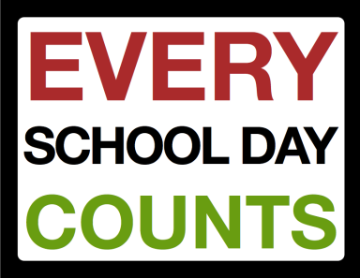
- Classroom discussion is a big part of the day. When students miss this, they won’t receive the possible extra information or they will miss out on time to bond with other students.
- Boosts self-esteem and gives students a sense of belonging as well as a sense of accomplishment.
- Students may feel as if they’re part of a “bigger picture” when they attend.
- Students are receiving at least two nutritious meals a day.
Consequences of missing school:
- Low grades, possibility of a delayed graduation date.
- The student will have a tendency to feel lost or confused.
- Greater chance of dropping out.
- Possibility of suspension, detention, or loss of credits.
- Some students may not form a bond with teachers or peers, resulting in them not wanting to come to school.
- If there’s a majority of students missing class every day, this could cause the teacher to postpone the lessons. As a result, this can cause other classmates to fall behind, as well as the absent student, resulting in them not being fully prepared for the next grade.

“Students that miss more than ten days of school are 20% less likely to graduate high school and have a 25% less chance of enrolling in college.” – Get Schooled Report


We know students can’t be at school every single day all year long, although we’d like them to be. We understand that obstacles come up such as sickness, appointments, or vacations. But what is a legitimate excuse for missing school? Here are some examples: Illness or injury, death in the family, health care appointments, court appearances, natural disasters, and outside educational opportunities
Parents and families are essential for their child’s attendance; they have the responsibility for making sure their child gets to school every day.

As a parent, you’re probably wondering what you can do to boost your child’s attendance. Here are some tips:
- Make getting your child to school on time a priority. Don’t let your child miss school without a legitimate reason.
- Be aware of the school’s attendance policy; let the school know if your child is gone for sickness, family emergencies, or vacations. This will help them gather missed assignments from their teachers and let the teachers know students aren’t just skipping school.
- Create a routine and stick to it, this will help your child not only become organized, but it will also make them realize that school is a priority, not an option. Also, make sure they get plenty of sleep!
- Monitor their home-work; this will also notify you of whether or not they’re struggling with classes.
- Let your child know that you’re just a phone call away if they really need you.
- Create a backup plan in case of an emergency and you’re unable to get your child to school. Converse with neighbors or other families of the same school and see if they can be available to pick up your child when needed.
Want more information on attendance? Visit this website: http://www.attendanceworks.org/wordpress/wp-content/uploads/2014/04/AWTeacherToolkitFINAL4.24.pdf
Teachers, parents aren’t the only people essential to student’s attendance. Here are some tips on how, you too, can help:
• Send home handouts and infographics with information and tips on attendance. Use parent teacher conferences or back-to-school nights to talk to parents about your expectations for their child’s attendance.
• Greet students in the morning, when you take attendance ask them how they’re doing, if they don’t seem well, ask if they’re okay or if they need anything, this will make them feel wanted at school.
• Offer incentives for attendance, such as: pizza parties, gold-stars, or certificates.



