SOUTH DAKOTA

MIGRANT EDUCATION PROGRAM

COMPREHENSIVE NEEDS ASSESSMENT

SUMMARY REPORT

August 2016

Prepared By Educational Research & Training Corporation

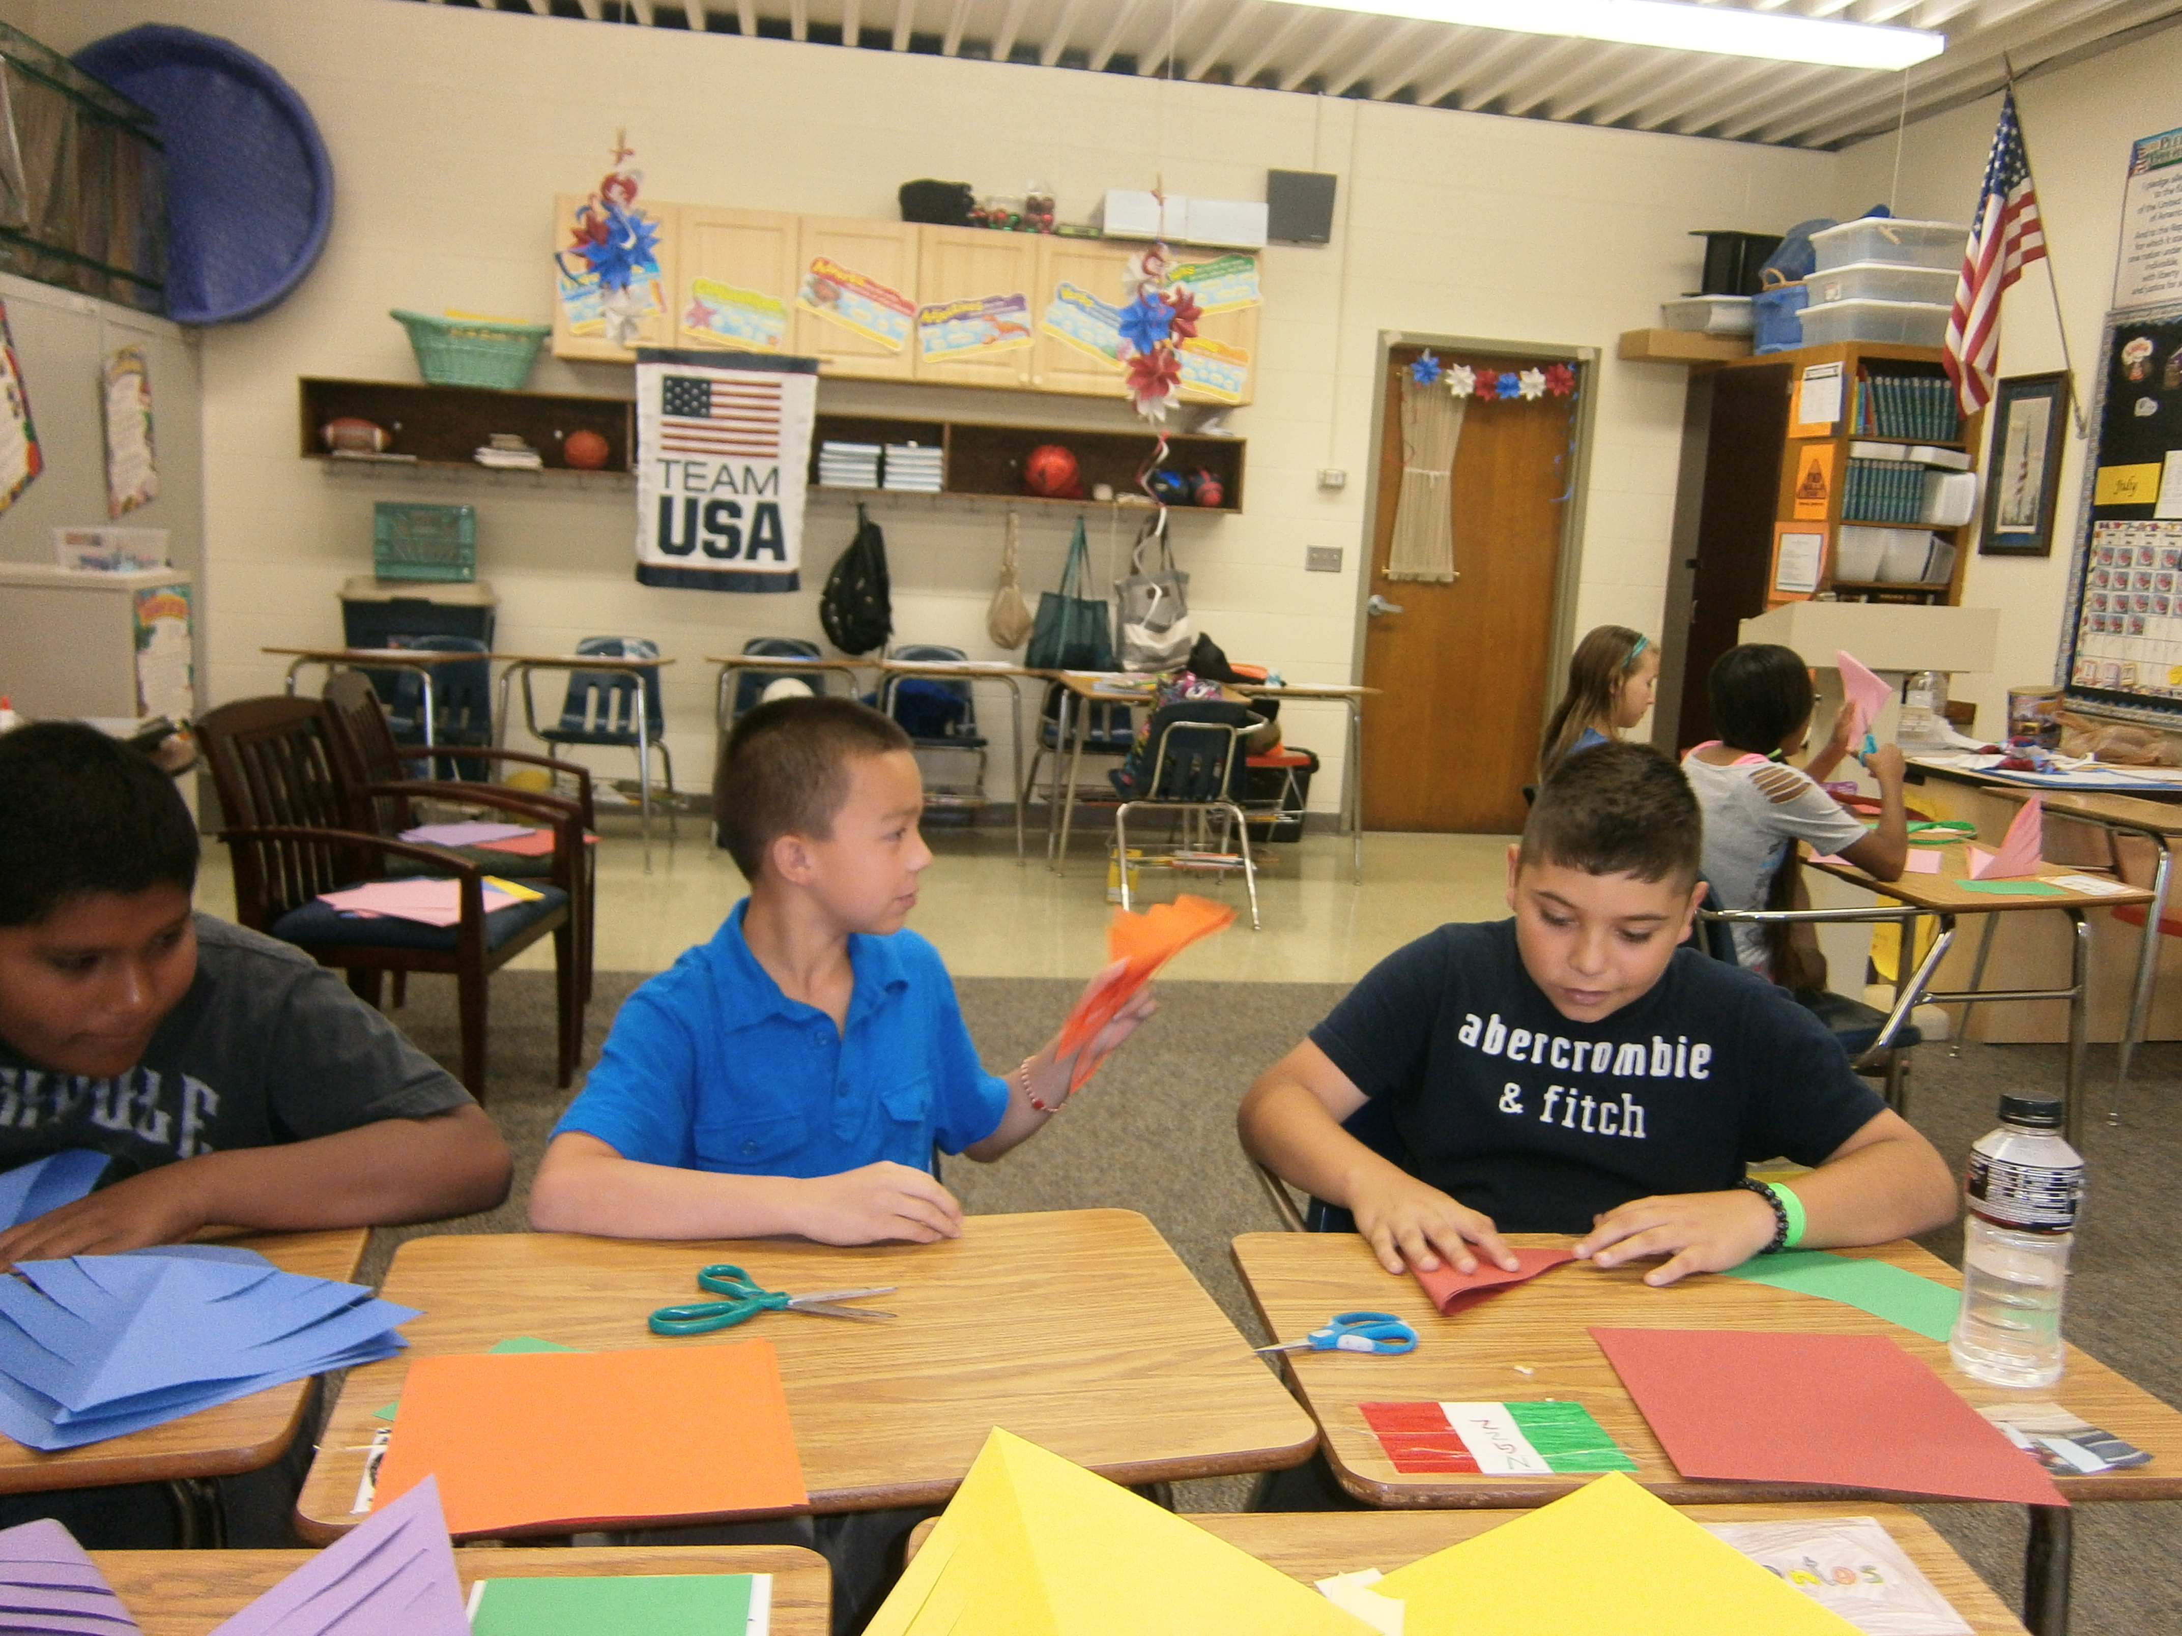

TABLE OF CONTENTS

1. Introduction and Purpose of Needs Assessment ………………….. 3

2. Implementation of the Process ……………………………………… 4

3. CNA Analysis and Results …………………………………………… 5

Assessment of Concern Statement 1: Low Graduation Rate ………. 5

Assessment of Concern Statement 2: Readiness for School ………… 9

Assessment of Concern Statement 3: Reading and Math …………… 13

Assessment of Concern Statement 4: Limited English Proficiency … 19

4. Summary …………………………………………………………….. 22

5. Conclusions …………………………………………………………….. 22

Appendix A – Needs Assessment Data Collection Forms and Surveys

Appendix B - Statistics

SOUTH DAKOTA MIGRANT EDUCATION PROGRAM
COMPREHENSIVE NEEDS ASSESSMENT 2016

Summary Report
Educational Research & Training Corporation

Introduction
The United States Office of Migrant Education requires that all states complete a comprehensive needs assessment in migrant education and use the results of that needs assessment to guide service delivery in the state. In addition, it is required that states use a continuous improvement model and evaluate the impact of the service delivery plan on student needs. The draft guidance from OME is clear in regard to the goal of the needs assessment and the service delivery plan as follows:
The primary purpose of the comprehensive needs assessment is to guide the overall design of the MEP on a statewide basis. It is not sufficient to simply document the need for the program (e.g., 50 percent of migrant students are not proficient in reading, or 30 percent of migrant students do not graduate from high school). Rather, SEAs and local operating agencies must identify the special educational needs of migrant children and determine the specific services that will help migrant children achieve the State’s measurable outcomes and performance targets. . . .
SEAs are also required to develop a comprehensive State plan for service delivery that describes the strategies the SEA will pursue on a statewide basis to help migrant children achieve the performance targets that the State has adopted for all children in reading and math, high school graduation, reducing school dropouts, school readiness (where applicable), and any other performance target that the State has identified for migrant children.
The SEA's comprehensive State plan for service delivery is the basis for the use of all MEP funds in the State. . . .

Each state is required by the U. S. Office of Migrant Education to implement a current comprehensive needs assessment of migrant education programs. The purpose of the needs assessment is to target service delivery as well as funding on areas of greatest need for priority migrant students, particularly in areas related to academic achievement.

Educational Research & Training Corporation (ERTC) from Colorado was engaged as the external contractor to facilitate the design and implementation of the comprehensive needs assessment process. ERTC also analyzed data collected from both the quantitative and qualitative assessments and provided consultation to the CNA Committee regarding interpretation of the data and the results. The CNA committee, consisting of the state migrant director and representatives from each of the local migrant programs, met on April 21, 2016 in Sioux Falls, South Dakota to review and revise the concern statements for the comprehensive needs assessment. The concern statements identified by the CNA Committee are as follows:

- We are concerned that there is a low graduation rate and retention rate for migrant students in South Dakota and there is a need to identify barriers to success to increase graduation rates for migrant students particularly for those that are priority for service students.

- We are concerned that South Dakota migrant students are not beginning school with basic readiness skills for reading, writing, and mathematics.

- We are concerned that instruction for South Dakota migrant students in language and mathematics may not be effectively targeting the foundational skills necessary to facilitate success at the appropriate grade levels to ensure that students are acquiring the basic building blocks necessary to master these skills and to ultimately graduate from high school.

- We are concerned that South Dakota migrant students that are English Language Learners may need additional help and instructional assistance in order to become proficient in English and proficient in critical content areas to increase the numbers of students who successfully graduate from high school.

These concern statements were used to guide the CNA process. The U.S. Office of Migrant Education requires that all states investigate the needs of pre-school migrant students to insure that all children have basic readiness for school. If the needs of pre-school aged children are being met across the state it is not required that pre-school be targeted in the service delivery plan. The results and the conclusions included in this report are provided to the South Dakota Migrant Education Program and the CNA Committee to facilitate the development of recommendations and measurable program outcomes for service delivery in the state of South Dakota to best meet the needs of migrant students.

Implementation of the Process

Following the revision of the concern statements, local migrant program directors were asked to assist in the identification of key data sources and processes to investigate each of the concerns. ERTC was charged with developing strategies to collect data that would result in a valid needs assessment. However, it was critical, due to the time constraints of local programs and staff limitations that the process be as efficient to implement as possible. ERTC created the following strategies to facilitate the investigation of needs related to the concern statements:

- In order to investigate the concern statement regarding low graduation rate the following strategies were used. A survey of migrant program administrators and teachers was developed to identify barriers to retention and graduation. The survey was administered to all staff providing services in South Dakota migrant programs in the spring of 2016. Because graduation and retention is closely tied to achievement data was also collected on student performance for the small percentage of migrant students (38%) who took the state assessment in reading and math. Data formats were created to collect achievement and demographic data as well as teacher ratings of student performance in relation to the state content standards in reading and math as well as a variety of student demographics. Teacher ratings are critical to gauge performance for the 62% of migrant students who did not take the state assessment. In addition, data was collected to identify student needs in these key content areas as part of a survey of migrant parents. The surveys were administered in both English and Spanish.

- In order to investigate the needs of pre-school aged migrant students a teacher survey was created and administered and the pre-school needs of students were discussed with migrant parents at local PAC meetings.

- In order to investigate the concern statements regarding migrant student needs to enhance proficiency in language arts and mathematics, ERTC developed a data collection format which collected state assessment data, English language proficiency scores, and a method in which teachers could rate individual student proficiency kindergarten through 12th grade in relation to skills identified in South Dakota state standards (see Appendix A for sample of data collection forms). The data was also used to identify migrant students who are at-risk of educational failure and have had their education interrupted within the last year (Priority For Service students). The data was collected on hard copy forms by teachers and then submitted to ERTC for analysis. Data was also collected to identify student needs through a survey of administrative and teaching staff for local South Dakota migrant programs. Finally data was collected to identify student needs as part of a survey of migrant parents. The surveys were administered in both English and Spanish. This data was also included as part of the CNA analysis to help identify reading and math needs for South Dakota migrant students.

- In order to investigate the concern statement regarding the needs of ELL migrant students: English language proficiency test scores were collected and a survey of administrators and teachers was completed. Finally, data was collected to identify student needs related to English language proficiency as part of a survey of migrant parents. The surveys were administered in both English and Spanish.

The data collection formats were reviewed and discussed with the state director and the local migrant program directors to insure that data was gathered using consistent, reliable, and valid methodology. All South Dakota migrant programs were provided electronic copies of all survey forms. Each migrant program was required to distribute the survey instruments to all teachers of migrant students in the spring and summer of 2016. Teachers were asked to collect data on all migrant students. The data was forwarded to the local program records clerks for input into the MAPS system. The survey of parents was completed by during the summer and fall of 2016.

CNA Analysis and Results

Concern Statement 1: We are concerned that there is a low graduation rate and retention rate for migrant students in South Dakota and there is a need to identify barriers to success to increase graduation rates for migrant students particularly for those that are priority for service students.

A sample of the survey administered to teachers and administrators to assess barriers to retention and graduation is included in Appendix A. Surveys were collected from 16 teachers and administrators regarding issues related to school retention and graduation for migrant students.
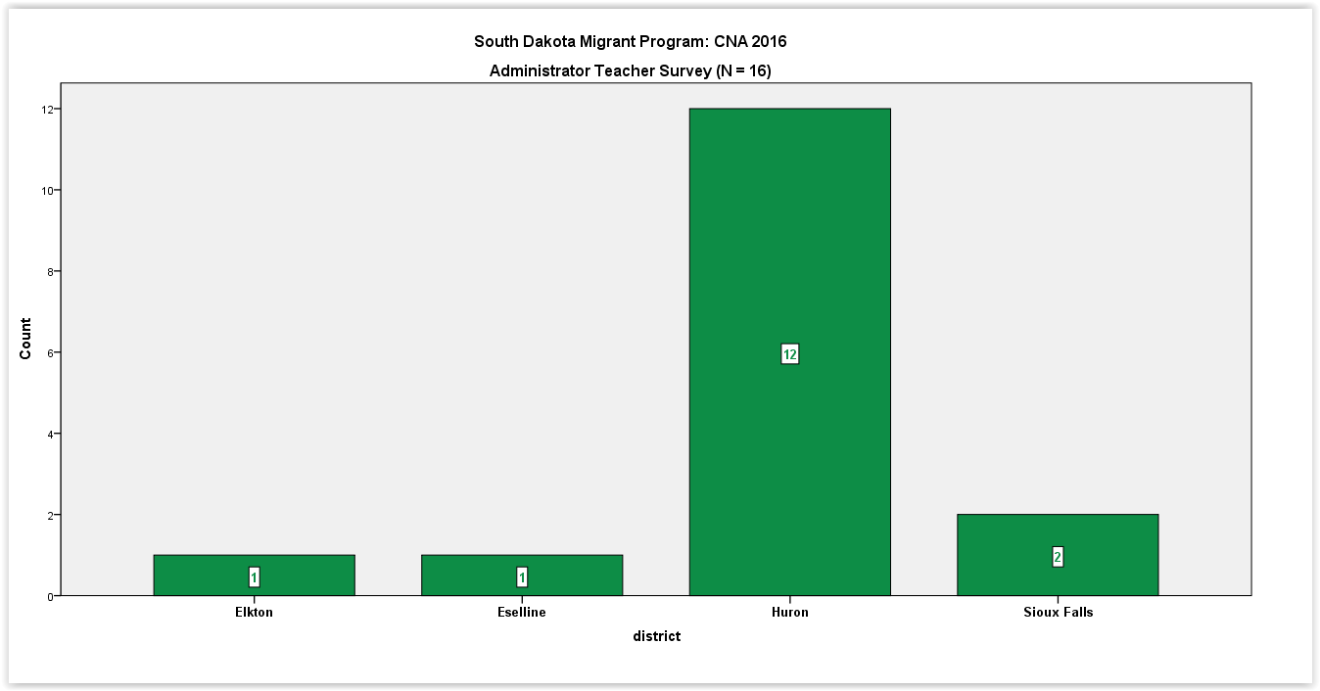

As part of the survey, teachers and administrators were asked to rate and rank order the importance of key barriers related to retention and graduation of migrant students. Respondents were asked to rate on a 6-point scale from Strongly Agree to Strongly Disagree the importance of nine critical barriers to successful school completion for migrant students. These nine barriers were identified based on feedback from the local migrant programs as well as current research regarding reasons for drop out and failure to graduate for migrant students. The nine barriers to high school graduation surveyed included lack of English proficiency, lack of pre-school services for migrant students, lack of reading readiness for school, lack of math readiness for school, missing transcripts and records, missing skills in reading comprehension, missing critical foundations in reading, missing critical foundations in math, and lack of bilingual instruction. The survey results are indicated on the chart following:
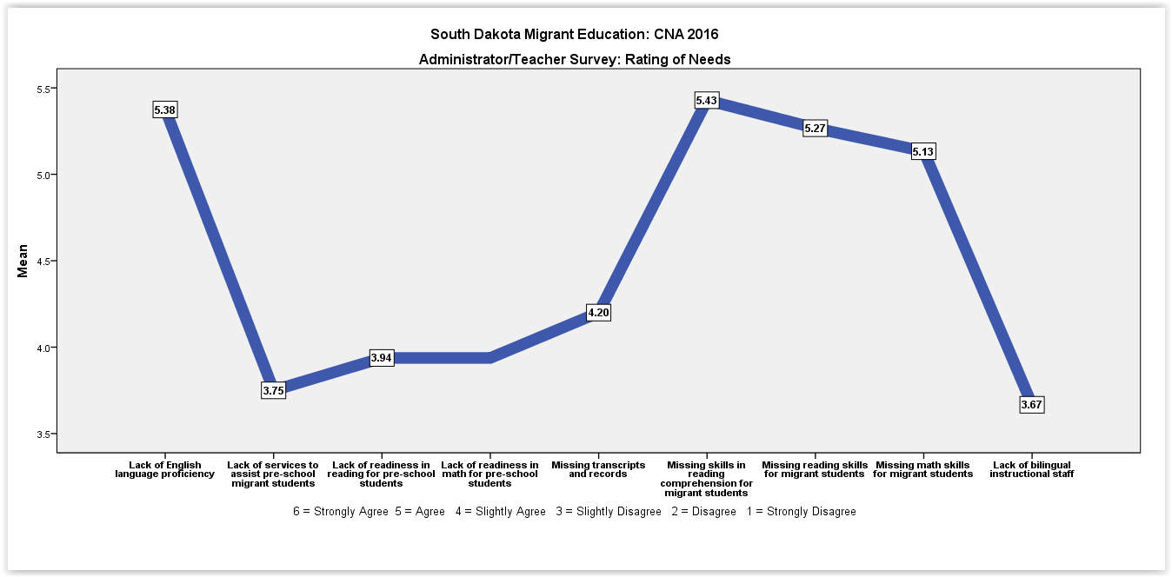

The top four barriers to retention and graduation for migrant students based on the data are:

1. Lack of English language proficiency
2. Missing skills in reading comprehension
3. Missing reading skills overall
4. Missing math skills overall

There were 248 students who completed the state assessment in reading (33% of the 757 total migrant students in South Dakota in 2016). Those completing the state assessment in reading scored on the average 1.44 (Below basic +) in reading across all grade levels. Teacher ratings were used to gather performance data on all migrant students including the majority of migrant students who do not take the state tests. Teacher ratings were collected for 318 students in reading and averaged 1.81 (Below basic +) across the reading standards. Both the state test scores and the teacher ratings show that migrant students in South Dakota are well below proficient in reading.
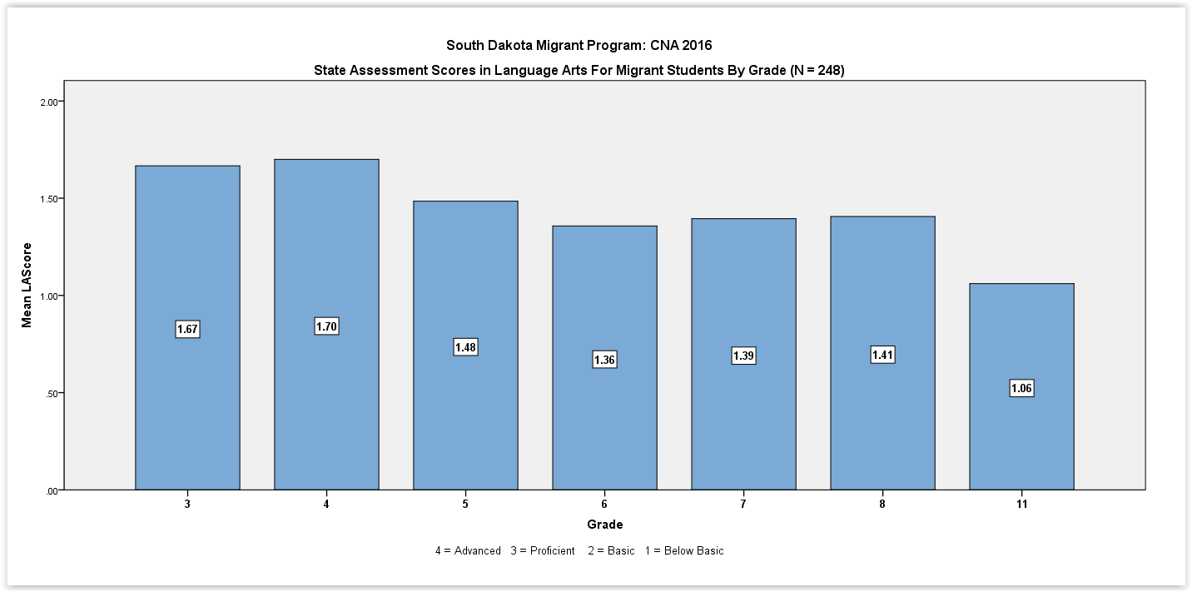

There were 277 students who completed the state assessment in math (37% of the 757 total migrant students in South Dakota in 2016). Those completing the state assessment in math scored on the average 1.37 (Below basic +) across all grade levels. Teacher ratings were used to gather performance data on all migrant students including the majority of migrant students who do not take the state tests. Teacher ratings were collected for 313 students in math and averaged 2.03 (Basic) across the math standards. Both the state test scores and the teacher ratings show that migrant students in South Dakota are well below proficient in math.

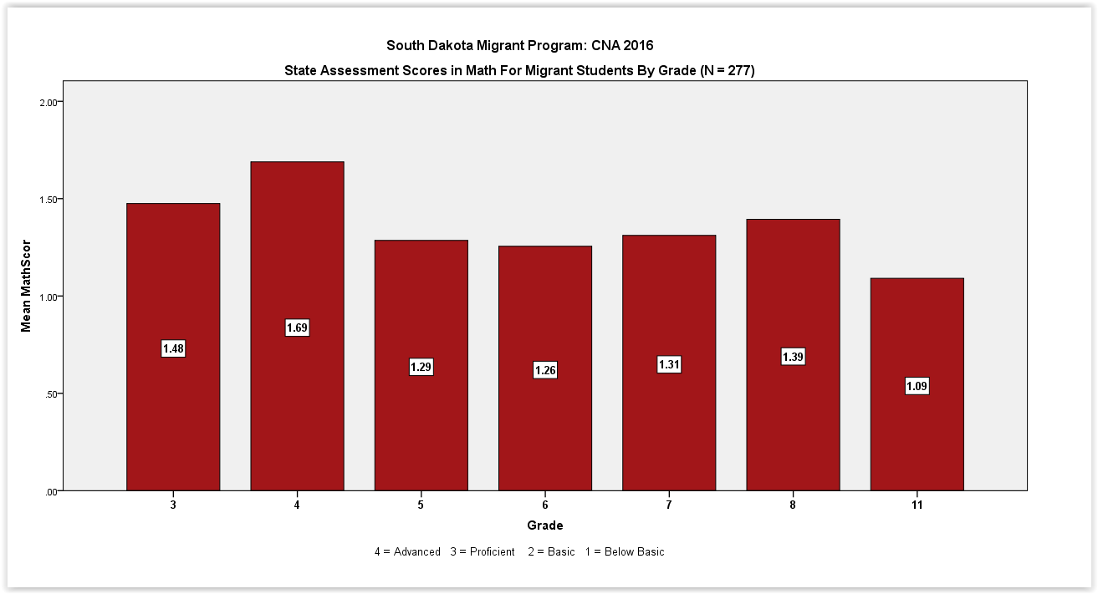

The state assessment scores and teacher ratings concur with the finding of the administrator teacher survey that both reading and math skills (as well as English language proficiency are) the most critical factors in student retention and graduation.

Concern Statement 2: We are concerned that South Dakota migrant students are not beginning school with basic readiness skills for reading, writing, and mathematics.

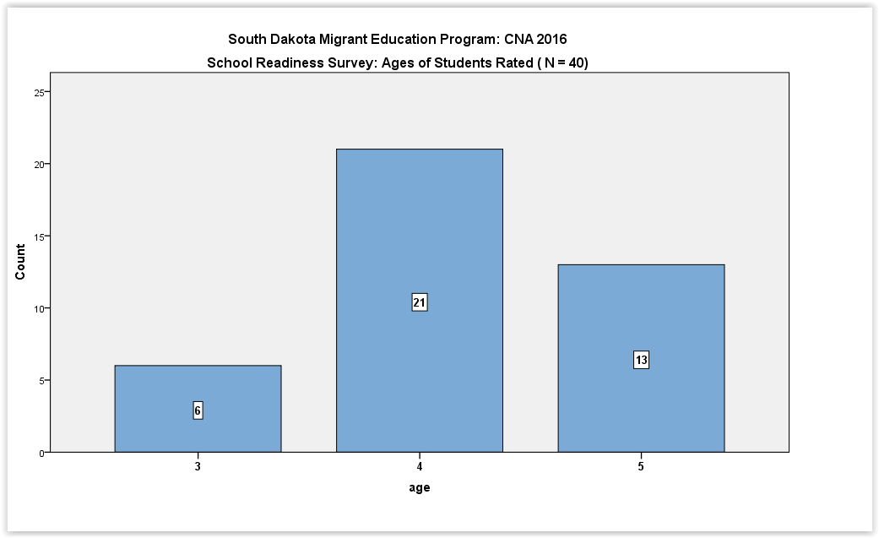
A sample of the protocol administered by teachers to assess student readiness for school is included in Appendix A. Protocol surveys were collected from 40 pre-school migrant students The ages of the students assessed is illustrated by the following chart.

As part of the protocol teachers were asked to rate the readiness of each student for school on a wide variety of skills. Respondents were asked to rate on a 5-point scale from Exceeds (standard) to Very Low (proficiency in skill). Five key skill areas were assessed: reading readiness, math readiness, motor skills, social/emotional readiness, and other readiness skills (e.g. knowing basic colors, following directions etc.). The survey results are indicated on the following chart:

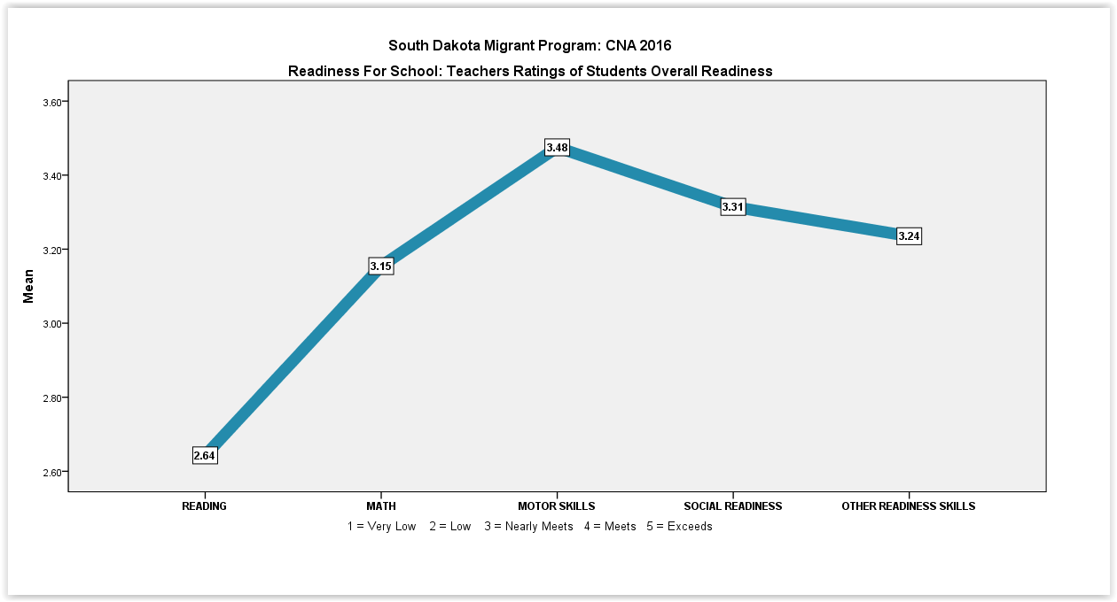

The two readiness skill areas with the highest needs were reading skills and math skills. The reading readiness skills most critical were phonemic awareness and basic rhyming skills.

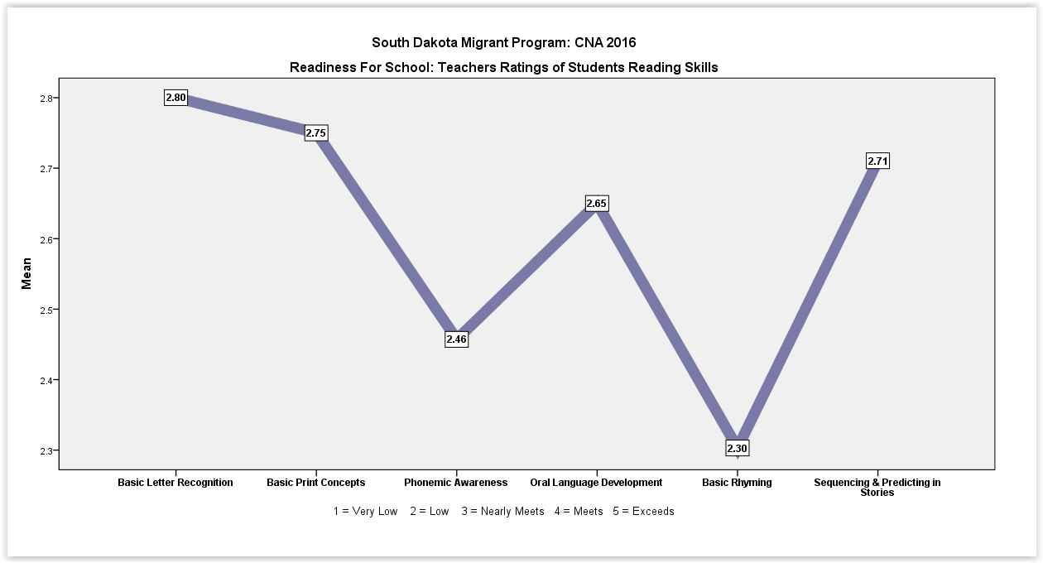

The math readiness skills most critical were recognizing basic shapes, more than/less concepts and number recognition (1-20).

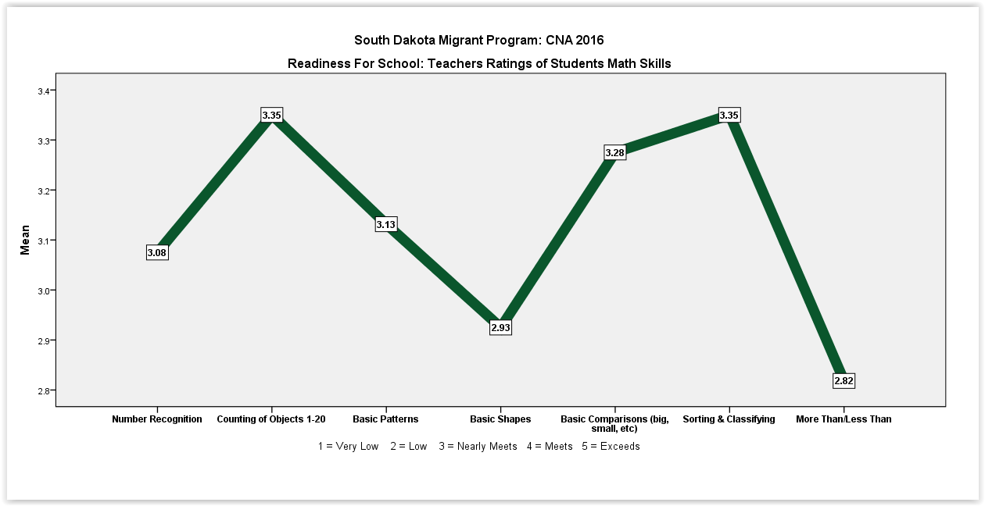
.

Concern Statement 3: We are concerned that instruction for South Dakota migrant students in language and mathematics may not be effectively targeting the foundational skills necessary to facilitate success at the appropriate grade levels to ensure that students are acquiring the basic building blocks necessary to master these skills and to ultimately graduate from high school.

Analysis: Data forms to assess reading and math needs were collected for 328 migrant students over the spring and summer of 2016. State assessment scores were not available for most students (only 33% or 287 students of 757 total migrant students had state assessment scores). However, teachers were asked to rate student proficiency according to grade level across all South Dakota state content standards in language arts and math using the same 4-point rubric incorporated into the state assessment (4 = Advanced, 3 = Proficient, 2 = Basic, 1 = Below Basic). Students were surveyed by teachers at grade levels K-12.

Language Arts: The following charts and tables provide the results for teacher ratings in the language arts content area.

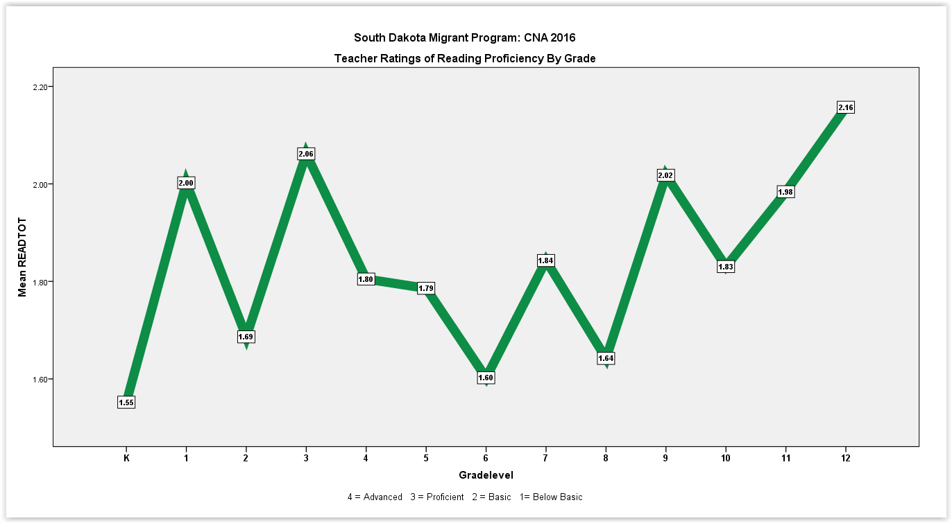
Students were identified as potential priority for service student’s base on the at-risk factor of performing at less than a proficient level in either reading or math. Two hundred ninety-seven students were identified as potential priority for service.

Number of Potential Priority For Service By Grade: Reading (N = 297)

Grade Level Total At-Risk Students Average Proficiency

Kindergarten 29 1.59
1st Grade 26 1.93
2nd Grade 37 1.62
3rd Grade 33 1.98
4th Grade 19 1.68
5th Grade 20 1.52
6th Grade 19 1.53
7th Grade 19 1.78
8th Grade 23 1.58
9th Grade 14 1.76
10th Grade 32 1.73
11th Grade 20 1.98
12th Grade 06 2.02

In terms of skills teachers rated the highest academic reading needs for all K-12 migrant students in South Dakota to be as follows:

Highest Areas of Need in Reading: All Migrant Students

Highest Areas of Need Average Rating

Evaluate arguments against claims in text 1.71

Analyze how and why ideas develop in text 1.74

Integrate and evaluate content from diverse media 1.74

In terms of skills teachers rated the highest academic reading needs for K-12 at-risk migrant students in South Dakota to be as follows:

Highest Areas of Need in Reading: Potential Priority For Service Migrant Students

Highest Areas of Need Average Rating

Evaluate arguments against claims in text 1.59

Integrate and evaluate content from diverse media 1.62

Analyze how and why ideas develop in text 1.63

Mathematics: The following charts and tables provide the results for teacher ratings in the mathematics content area.

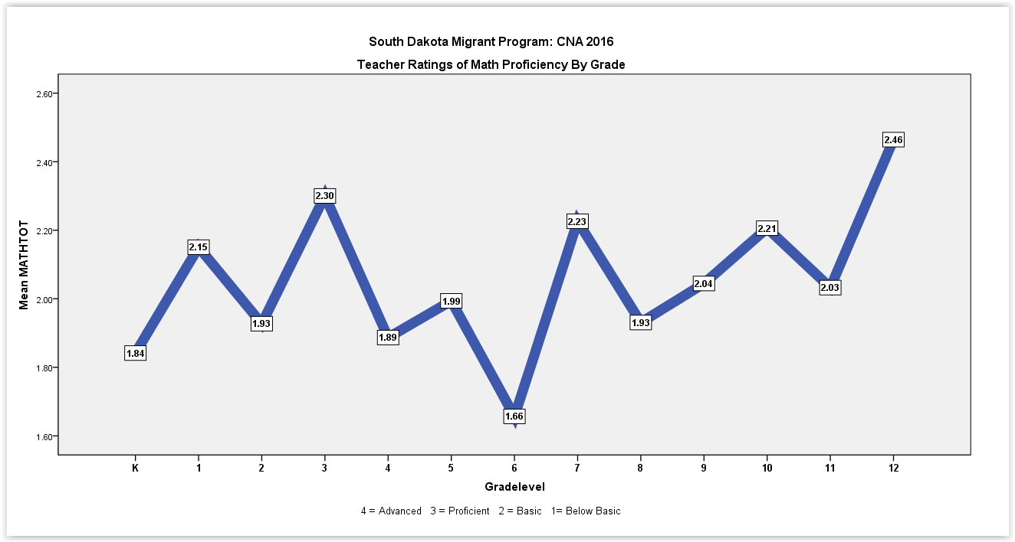

Students were identified as potential priority for service student’s base on the at-risk factor of performing at less than a proficient level in either reading or math. Two hundred ninety-seven students were identified as potential priority for service.

Number of Potential Priority For Service By Grade: Math (N = 297)

Grade Level Total At-Risk Students Average Proficiency

Kindergarten 29 1.80
1st Grade 26 2.09
2nd Grade 37 1.87
3rd Grade 33 2.21
4th Grade 19 1.77
5th Grade 20 1.78
6th Grade 19 1.66
7th Grade 19 2.25
8th Grade 23 1.93
9th Grade 14 1.90
10th Grade 32 2.20
11th Grade 20 1.96
12th Grade 06 2.38

In terms of skills teachers rated the highest academic reading needs for all K-12 migrant students in South Dakota to be as follows:

Highest Areas of Need in Math: All Migrant Students

Highest Areas of Need Average Rating

Construct viable arguments and critique reasoning in math 1.76

Reason abstractly and quantitatively in math 1.93

Model math in everyday life 2.04

In terms of skills teachers rated the highest academic math needs for K-12 at-risk migrant students in South Dakota to be as follows:

Highest Areas of Need in Math: Potential Priority For Service Migrant Students

Highest Areas of Need Average Rating

Construct viable arguments and critique reasoning in math 1.67

Reason abstractly and quantitatively in math 1.86

Model math in everyday life 1.98

A survey was completed to assess migrant student needs by 16 administrators and teachers of migrant students indicated that the first highest need was missing reading comprehension skills and the fourth highest need was missing foundational math skills.
Finally, a survey of 34 migrant parents (without pre-school children) indicated the need to improve reading skills, writing skills and math skills as the top three highest academic need for all South Dakota migrant students. See following chart on following page for results.

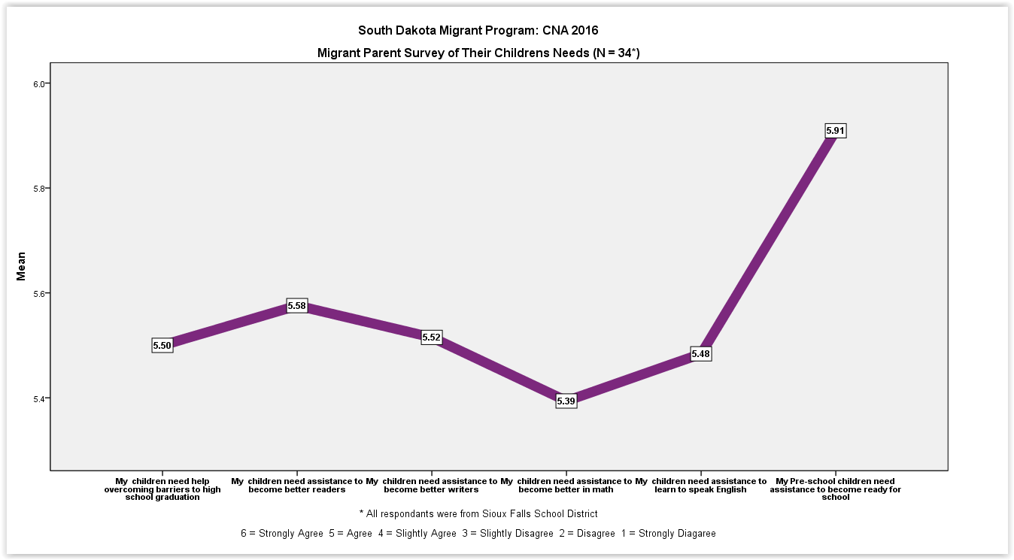
Concern Statement 4: We are concerned that South Dakota migrant students that are English Language Learners may need additional help and instructional assistance in order to become proficient in English and proficient in critical content areas to increase the numbers of students who successfully graduate from high school.

Analysis: There were 221 limited English proficient migrant students tested in South Dakota in 2016. The data collected from ACCESS scores and teacher ratings was used to identify ELL needs. The ACCESS scores across grade levels indicated that the average student was limited English proficient but progressing toward proficiency.
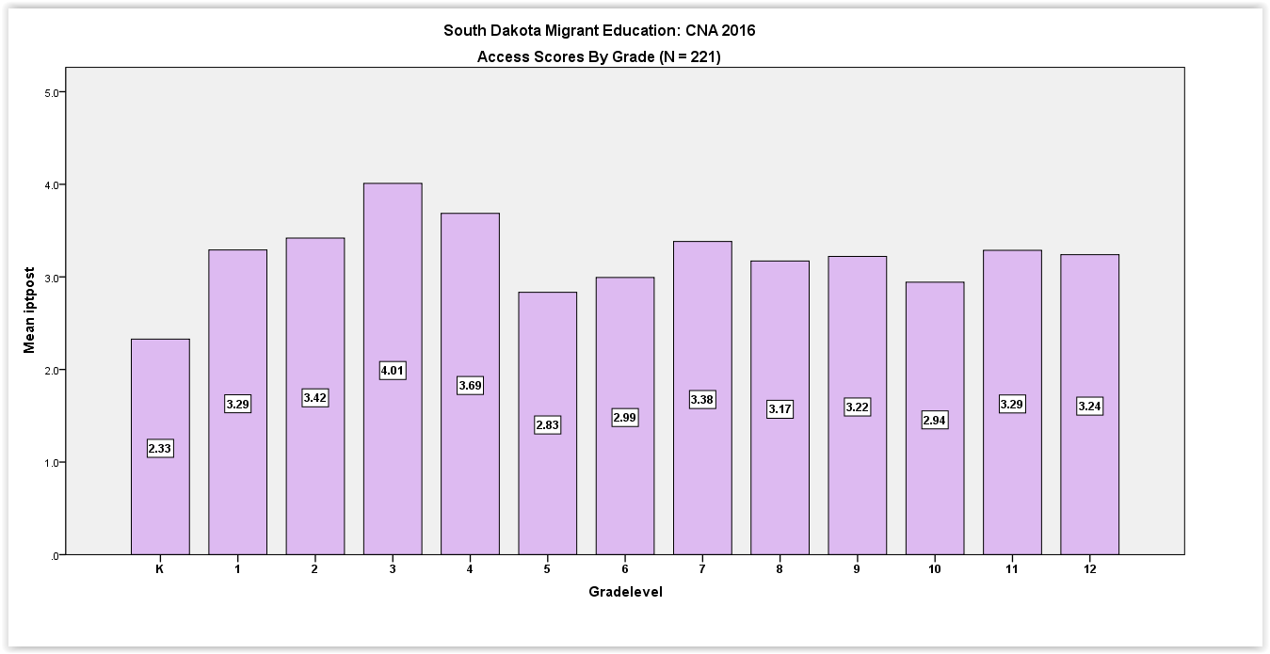

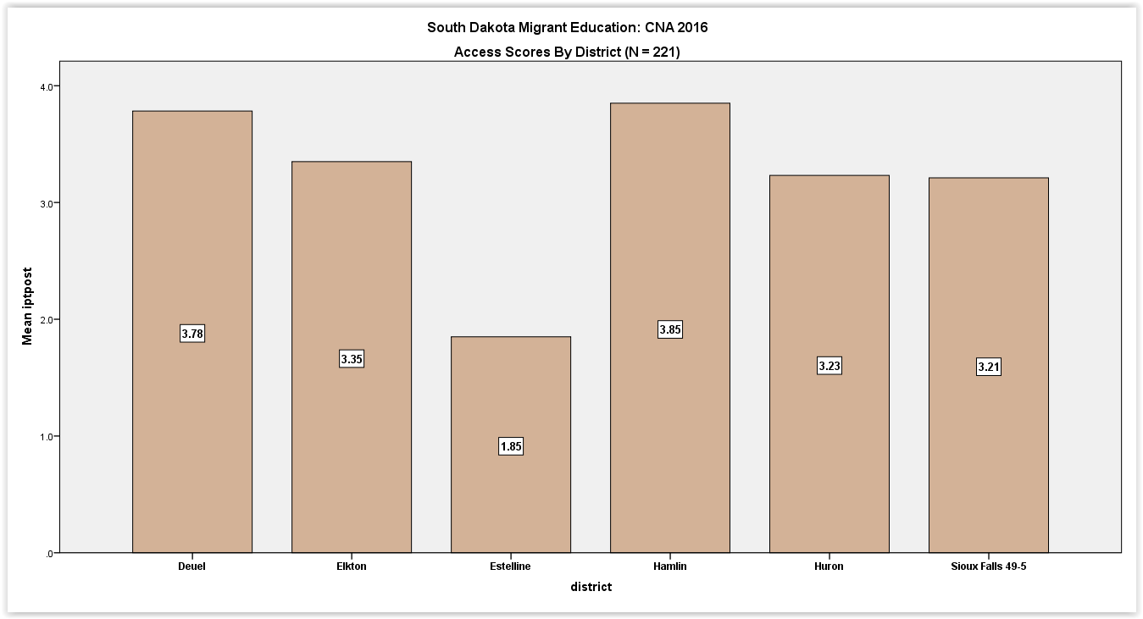

Data results indicate that there is a direct correlation between limited English proficiency and mathematics as well as reading proficiency. ACCESS scores correlated with teacher ratings in math and reading (Spearman correlation) significant at the .01 level. This implies that reading and math proficiency as rated by teachers is directly related to English language proficiency. Teachers also rated limited English proficient student in relation to language arts and math standards. The following tables indicate the areas of highest need for LEP students in language arts and math.

Highest Areas of Need in Reading: LEP Migrant Students

Highest Areas of Need Average Rating

Evaluate arguments against claims in text 1.52

Integrate and evaluate content from diverse media 1.55

Analyze how and why ideas develop in text 1.55

Highest Areas of Need in Math: LEP Migrant Students

Highest Areas of Need Average Rating

Construct viable arguments and critique reasoning in math 1.64

Reason abstractly and quantitatively in math 1.87

Model math in everyday life 1.94

Finally, on the administrator teacher survey limited English proficiency was rated as the highest barrier to retention and graduation for migrant students.

Summary:

- The overall assessment of needs in relation to concern statement 1 (low graduation rate and retention rate for migrant students in South Dakota): The data indicated that the key barriers to retention and graduation were: lack of English language proficiency; missing skills in reading comprehension; missing reading skills overall; and missing math skills overall.
- The overall assessment of needs in relation to concern statement 2 (pre-school migrant students are not ready for school): The data indicated that critical readiness needs were in the areas of reading and math. In reading the critical readiness skills are: phonemic awareness and basic rhyming skills. In math the critical readiness needs are: recognizing basic shapes, more than/less concepts and number recognition (1-20).
- The overall assessment of needs in relation to concern statement 3 (missing foundational skills in reading and math impacting academic achievement): The data indicated that low reading and math skills were the highest needs of all migrant students as well as those who are priority for service. The highest needs in reading are: evaluate arguments against claims in text; integrate and evaluate content from diverse media; and analyze how and why ideas develop in text. The highest needs in math were: construct viable arguments and critique reasoning in math; reason abstractly and quantitatively in math; and model math in everyday life.
- The overall assessment of needs in relation concern statement 4 (limited English proficiency as a barrier to success): The data indicated the highest need for administrators and teachers was to limited English proficiency for South Dakota migrant students. Students across all grade levels average less than proficient in English and there are very large numbers of LEP students in the South Dakota migrant program. Limited English proficiency correlates significantly with reading and math achievement (i.e. the less English proficient the less proficient in reading and math students are). Finally the highest areas of need in reading and math for LEP migrant students are exactly the same as for all migrant students and for priority for service students.

Conclusions

This report is submitted to the State Migrant Director and the South Dakota CNA committee for review. The purpose of this report is to provide the State and the CNA committee with the data and analysis necessary to form recommendations regarding the service delivery plan for migrant education in the State of South Dakota. These recommendations should be used to formulate measurable program outcomes to meet the needs of priority for service migrant students (as required by the U.S. Office of Migrant Education). The measurable outcomes (based on the comprehensive needs assessment and the recommendations) are to be used to evaluate the impact and effectiveness of the South Dakota Migrant Program to meet the needs of migrant students. The recommendations and measurable outcomes should be included in the South Dakota Service Delivery Plan. All migrant programs nationally are evaluated using this continuous improvement system.

Appendix A

Data Collection Forms

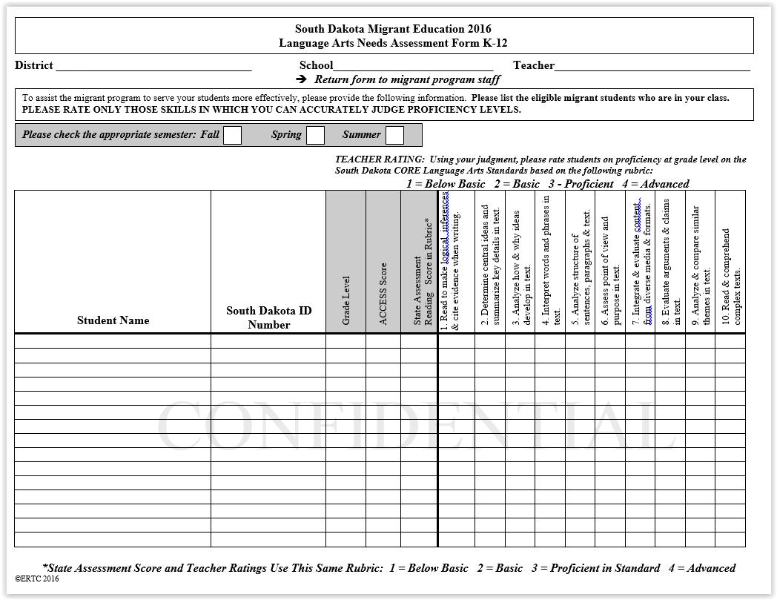
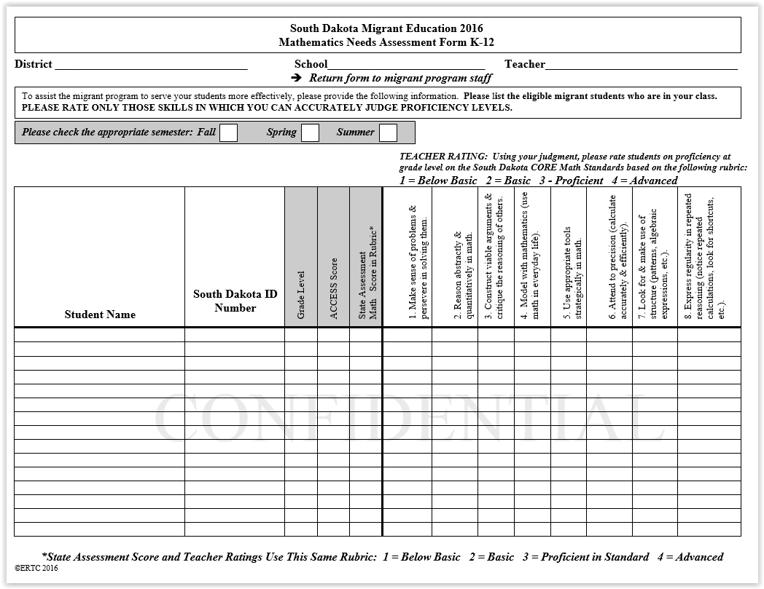
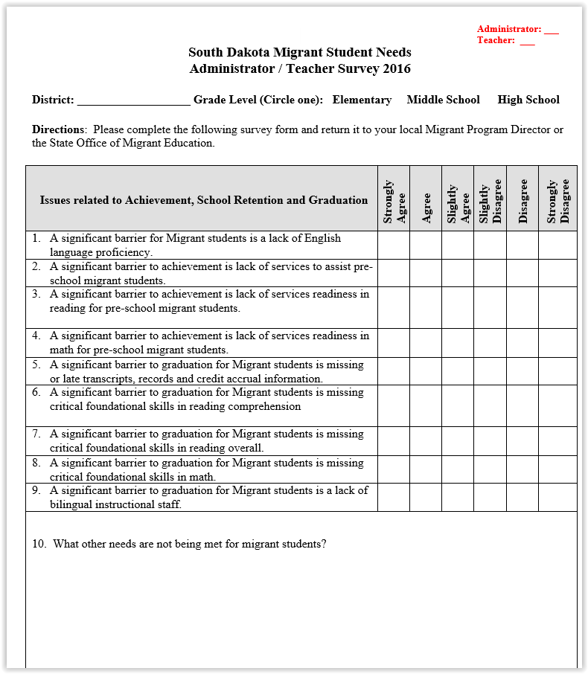
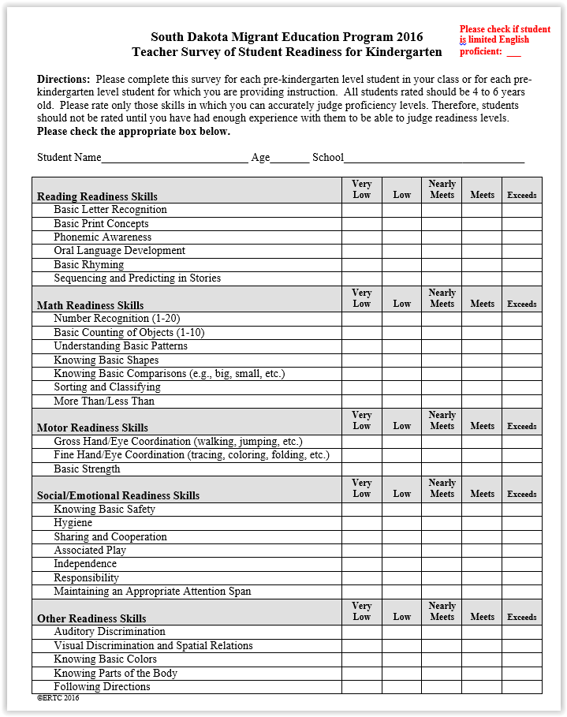
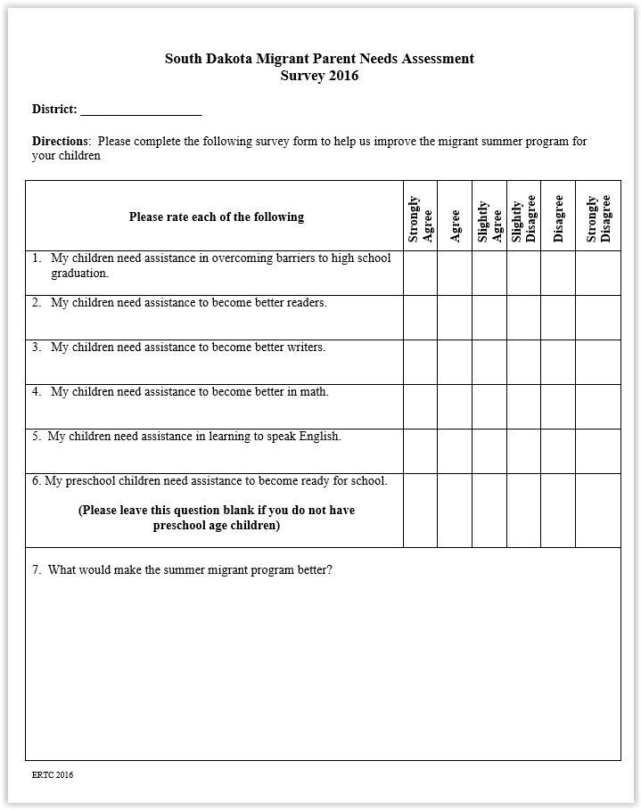

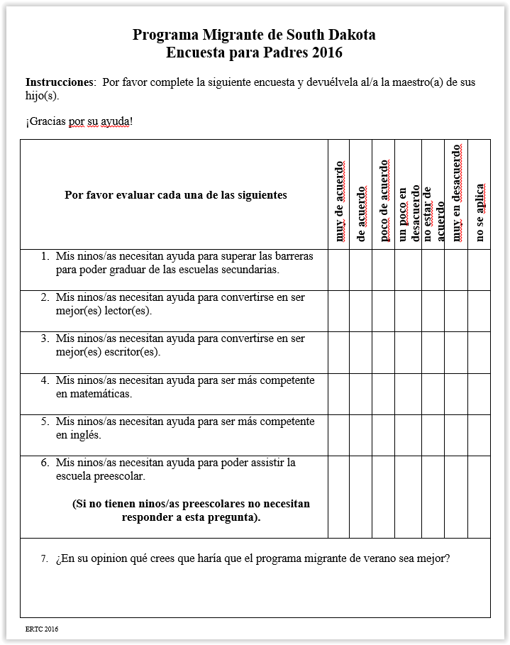

Appendix B

Statistics

